The double constraints of convention and cognition in successful graphic design

Pino Trogu
cognition, context, convention, shared knowledge, working memory

Using insights from cognitive psychology this paper develops a theoretical orientation to graphic design critical of Bertin’s structuralist doctrines, but highly respectful of the insights offered by art historians like Ernst Gombrich, who stress the sociality and cultural contingency of visual forms. The paper discusses the constraints imposed by cultural expectations as well as the universal constraints imposed by working memory. Cognitive science has found that closure must occur in any perception within a stringent time limitation of just a few seconds. While this time limitation cannot be overcome directly, the designer can employ culturally conditioned devices that minimize its adverse effects. This speed-up effort can be aided by taking into account the finding that visual experience is unconsciously attended by a verbal component – a duality that should be exploited even when designing a mute visual artifact such as a poster. In sum, perception is construction, and an effective graphic can overcome the inherent polysemy of signs and forms only by exploiting the shared knowledge that is quickly available to the viewer’s mind within a specific cultural moment. Visual examples, including subway maps, and an 1869 historical map are used to illustrate the key concepts of the paper.
1 A beautiful design that did not work
In 1972 the New York City Transit Authority introduced a beautiful map of its subway system that was radically different from previous ones (Fig. 1). It was introduced in 1972, but just seven years later, after many complaints from confused subway riders, it was discontinued and a new map issued, with a more traditional design that has survived to the present day basically unchanged (Lloyd & Ovenden, 2012).
The discontinued map was by the Italian designer Massimo Vignelli, and is regarded as a monument to modernism, a graphic nod to abstract art, and a model of simplicity, with its clean, bright-colored lines admitting only verticals, horizontals, and forty-five degree angles. The map is indeed a beauty to behold, a designer’s counterpoint to Mondrian’s Broadway Boogie-Woogie (Fig. 2).
Figure 1: New York City subway map, detail, 1972. Massimo Vignelli, designer. Revised: February 1978. Dim: 45 x 56 cm (18 x 22 inches). Pino Trogu collection. MTA, 1978.
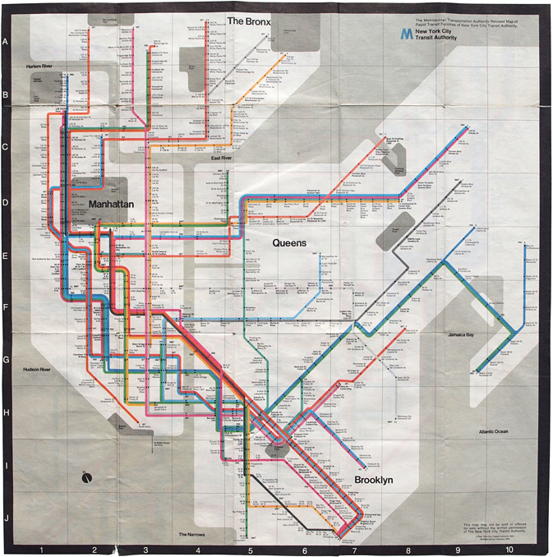
Figure 2: Piet Mondrian, Broadway Boogie-Woogie, 1943. Oil on canvas. Dim. 127 x 127 cm (50 x 50 inches), Museum of Modern Art, New York. Redrawing by Pino Trogu, June 2013.
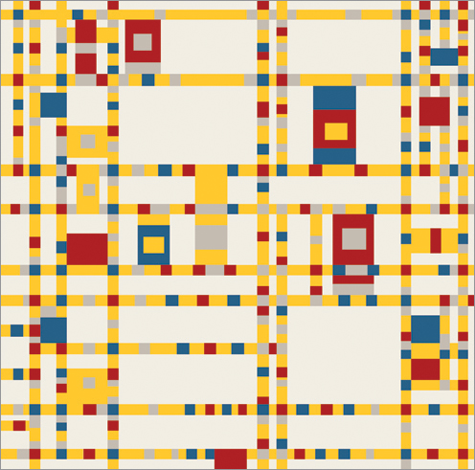

By contrast here is its more complex replacement (Fig. 3), which, with modest changes, has satisfied subway riders for the past 34 years.
Figure 3: New York City subway map, 1979. Michael Hertz, designer. Revised: Summer 1985. Dim: 58 x 71 cm (23 x 28 inches). Pino Trogu collection. MTA, 1985.
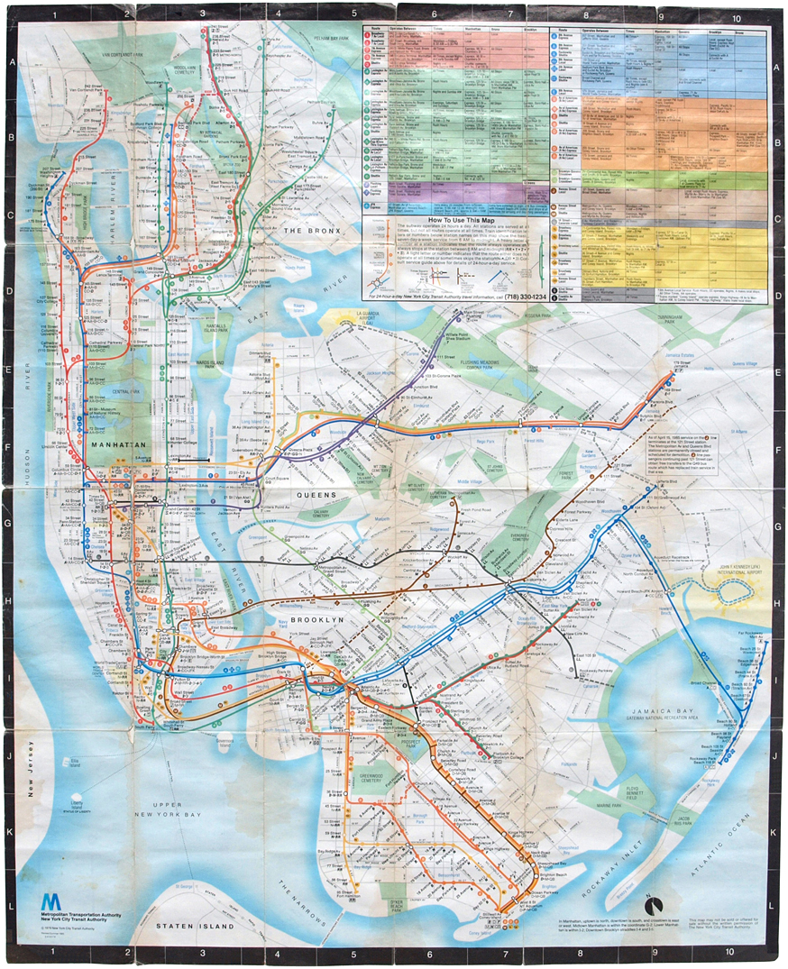

I’ll try to explain rather fully by the end of this paper why the Vignelli failed and why its replacement continues to succeed. I’ll apply some principles gleaned from art history, linguistics, and, above all, from cognitive psychology. My broader goal is much more general than to critique Vignelli’s map. I shall point to some general reasons for communicative success and failure in the world of graphic design – not to offer a formula for communicative and aesthetic success, but on the contrary, to show why historical and cultural considerations are always central to effective design.
The ad hoc approach is a quite general principle because viewer responses are always determined by a specific cultural and historical context. My view thus conforms more with the historicist tradition in art history represented by Ernst Gombrich rather than with the structuralist tradition represented by the influential French cartographer and information visualization theorist Jacques Bertin. A fine practitioner, Bertin can be a useful guide in particular instances despite the shortcomings of his structuralist theory, which wrongly holds that graphics use an armory of “monosemic” signs (Bertin, 1983).
Bertin’s word “monosemic” should be a warning signal to anyone steeped in art history. Forms are inherently polysemic. A form, Gombrich persuasively argues, does not have even a definite shape until it has been interpreted by an audience. He showed that there is no pre-interpretive “given” in the visual world – except perhaps the human face and smile to which infants readily respond at birth. Steeped in the technical literature of the psychology of perception as well as the history of art and design, Gombrich is the better guide to graphic artists.
Since the era of Gombrich’s Art and Illusion and his other masterpieces (Gombrich, 1960), cognitive science has yielded further fundamental insights, especially those regarding the function and limitations of working memory – a narrow, unstable territory through which all conscious mental activity must pass. A greater awareness of Gombrich’s work plus these recent insights may help design teachers and practitioners become more effective. They have certainly helped me both in my teaching and my practical work. In this essay, constrained by length limits, my focus will be on the communicative task of graphic design more than on aesthetics – though communicative closure and aesthetic pleasure are deeply connected psychologically (Butter, 2011).
2 The peephole of working memory
It has been useful in cognitive research to think of the mind as containing two main cognitive modules – working memory and long-term memory. Working memory is a stern disciplinarian. ‘Information is only held in working memory from between one-tenth of a second and, at most, a few seconds’ (Ware, 2008: 115). When people look at a graphic their perceptual activity back and forth between working memory and long-term memory is being recycled every few seconds trying to achieve closure, as all the while the narrow window constantly moves forward in time. If meaningful closure among the visual items is not reached in a very few seconds, some items will fall out of memory, and the process must be restarted. The ephemeral nature of this very small window of time is a key fact that should be taken to heart by every conscientious designer: If the mind does not reach meaningful closure quickly, confusion is the result, as the New York subway riders complained when trying to use Vignelli’s map. Key elements of Vignelli’s design kept receding from their working memories, and the interpretive process had to begin again.
The reason for such confusion was explained in a 1956 paper by George A. Miller, which began with the memorable sentence: ‘My problem is that I have been persecuted by an integer.’ His essay was entitled: “The magical number seven, plus or minus two: some limits on our capacity for processing information.” It marked a milestone in psychology. Miller found that we can never keep more than about seven “chunks” (Miller’s word) of information in our immediate memory at the same time. This justifies his use of the work “chunk.” For if you can chunk the items – for instance the digits in your social security number (your “tax” number) then you can remember that number more readily. That’s why social security numbers are written in chunked groups: 434-65-9623. Here we have 8 digits but just 3 chunks, making the number much easier to handle and recall than 4-3-4-6-5-9-6-2-3.
Current research has further refined Miller’s insight, and has put the average number of items as closer to four than to seven. More important, it has found that the real limitation on our “site of awareness” is determined less by number items than by number of seconds before items drop out of awareness. For example, it has been found that Chinese students doing mental math can keep in mind more integers than American or European students can, in part because the number words in Chinese have fewer syllables, and hence take a shorter time to process (Geary, Bow-Thomas, Liu, & Siegler, 1996).
3 The duality of working memory: the verbal and the visual
Alan Baddeley has developed a well-accepted model of working memory which consists of two basic components. One is the articulatory or phonological loop, that provides a temporary verbal storage, even in the case of visually presented materials. He found that we unconsciously name objects, as they are presented, in a process called “sub-vocalization” – a kind of inner speech (Baddeley, 1999: 49-66). It has been shown since the 1970s that we subvocalize when viewing pictures (Noizet & Pynte, 1976). Such naming plays a strong role for gaining rapid closure in the successful perception of a visual organization, just as it does in the understanding of a verbal organization (Logie, 1996).
The second component of working memory, is the visuo-spatial sketch pad involved in temporary retention of visual and spatial information. ‘As the phonological loop has been linked to the speech system, the visuo-spatial sketch pad has been linked to the control and production of physical movement’ (Logie, 1996: 53). The tight visual-verbal interaction that takes place within the process of working memory suggests a distributed effort among all the components of the system, especially between the phonological loop and the visuo-spatial sketch pad. And therein lies a key point for designers: with or without text in the design, the role of the verbal seems to be just as important as the visual in processing visual information! Quick recognition of representations is connected with quick naming of them – a feature that can be reinforced in graphic design with its extensive use of text. It’s useful for designers to be aware of how universal subvocalization is. The silent act of looking at pictures is accompanied by an activity of inner speech, just as silent reading is (Baddeley, 1999).
This structural connection between the visual and the verbal is especially salient when the design elements use letters. Today the American insurance company GEICO is remembered by consumers, among other things, through the link between the sound of the word GEICO and the sound of the word gecko (GEICO, 2012). An anthropomorphic gecko (Fig. 4) is one of the spokespersons featured in the company’s advertisements. The ad series started with a play on mistaken identity and wrong phone numbers (Geico, gecko?) and the mnemonic power of this sound similarity has sustained the effectiveness of the campaign. The novelty in the ads is the human-like gecko – already a charming character – but the ad works because people remember GEICO and the sound associated with it by remembering the sound associated with gecko. Although made with advanced computer visuals, the ads work first and foremost on the aural dimension of the words that are spoken in various kinds of British accents.
Figure 4: GEICO. Government Employee Insurance Company, USA. Direct mail advertisement, 2013. Pino Trogu collection.


4 Convention and context (1): shared knowledge
Background knowledge is always required in order to make sense of even purely formal inputs. The false belief in universal trans-historical forms is called “The Myth of the Given” (Sellars 1956). Every form we perceive is post-perceptum (Cleveland & McGill, 1984; Casner & Larkin, 1989; Carpenter & Shah, 1998; Cook, 2006; Canham & Hegarty, 2010; Hinze et al, 2013). The simplest requirement is that we complete a vague whole form in our minds even though we are glimpsing only a part. We achieve closure because we know from past experience what sort of thing it is. When we see the image of the side of a house we mentally complete the object from prior knowledge even when we do not see what the other sides look like.
Figure 5: View from apartment window. San Francisco, California, 2013.


A visitor from the Middle Ages would not make much sense of the two autos in the view from the window in Fig 5. Designers are instinctively aware that viewers who have the needed background knowledge, will be more quick to understand the visual references in a graphic. In visual interpretation, as in speech, the most important factor in gaining rapid closure and the ability to gain new knowledge is the amount of relevant knowledge that the viewer already possesses. Hence one of the chief problems to be solved by a designer is to make sure that the taken-for-granted knowledge needed to understand the graphic rapidly is actually shared among the target viewers.
For instance, one needs to know at a minimum that the sign depicted in Fig. 6 is not an entry to a theater, say, or to a conservative Jewish prayer service where men and women must be separated.
Figure 6: Unisex restroom sign. Wikimedia Commons, public domain, 2013.

5 Convention and context (2): polysemy and genre
That the very form of a design element is never a brute given is often illustrated by the rabbit-duck phenomenon (Fig. 7), also presented in Art and Illusion (Gombrich, 1960: 5).
Figure 7: Rabbit or duck? One can perceive one or the other but not both at the same time. Wikimedia Commons, public domain, 2013.
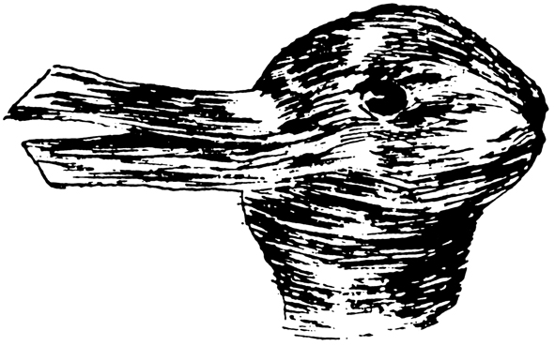

In Cognition and Categorization (Rosch & Lloyd, 1978), Eleanor Rosch and other researchers give scientific support to the principle that genre-classification is necessary to meaningful perception. An overarching sense of the kind of whole we are seeing piecemeal through our momentary window of working memory is necessary to restrict the polysemy of words or images and make ongoing sense of the parts. George A. Miller once observed that the initial meaning that we posit for the word “shot” will be different, depending on whether the word is used on a golf course, a rifle range, or in a bar (Miller, 1999). His point has sometimes been oversimplified as exhibiting the special problem of homonyms in language – different words having the same sound: sun-son, tail-tale. But his point was far more general. Words and visual images are always potentially polysemous, meaning that ambiguity always threatens as it did in the unisex design. One of the designer’s jobs is to supply what is needed to imply a certain kind of meaning. Genre provides a context, and context a genre: Is this a unisex restroom or a Jewish worship service? Convention, context, and genre all converge on the same function: Given the inherent polysemy of visual forms, genre and context, convention, all help reduce the inherent ambiguity of forms.
Gombrich made the point elegantly when he explained the naiveté of the scientists who had put a design into the Pioneer Spacecraft meant to communicate something about human civilization for the benefit of beings in outer space who would lack knowledge not only of the represented objects, but also of our conventions of representation (Gombrich, 1982: 150-151). For instance, the right side of the woman’s face is narrower than her left (Fig. 8). What sort of lopsided creature is that?
Figure 8: Golden plaque from Pioneer 10 spacecraft. Dim. 23 x 15 cm (9 x 6 inches). NASA, 1972. Wikimedia Commons, public domain, 2013.
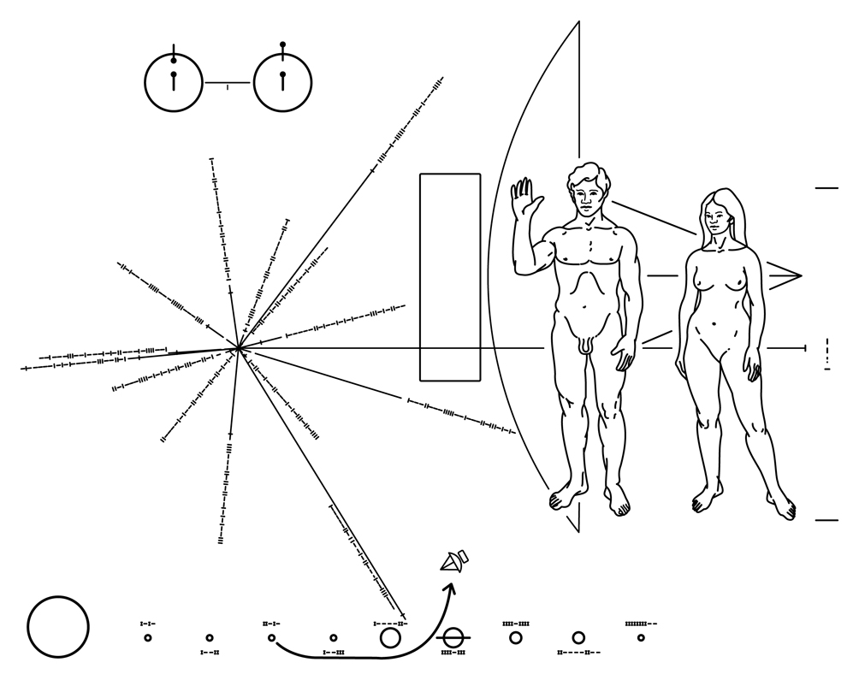

But there were reasonable limits to Gombrich’s conventionalism. Some elements of spatial representation are universal. He did not present himself as an absolute conventionalist in visual design. He recognized that some conventions such as foreshortening have an absolute basis in physics and the universal psychology of perception. Our perceptual systems have evolved to maneuver ourselves in space, so that we don’t run into walls. Hence our visual system must accurately map onto real space, otherwise we could not survive. He pointed out that we can still interpret representations in cave drawings more than thirty thousand years old. So there is something absolute in our mappings of spatial relations, and Gombrich had only praise for the brilliant naturalism of the 33,000-year-old drawings in the caves of Chauvet (Gombrich, 1996). But he also placed strict limits on this concession to naturalism. The very form of an image is contingent upon its meaning as interpreted by an audience through background knowledge of convention, context, and genre.
6 Convention and context (3): perception as construction
Cognitive science and history are thus telling us that the viewer’s interpretation of a graphic or a text is highly dependent on elements in long-term memory which are not themselves given in the graphic itself. This implies that all meaningful perception is not just reception but also construction based on prior knowledge. The more quickly accessible that relevant knowledge is, the more rapidly closure can be achieved. Cognitive scientists therefore lay great stress on the concept of accessibility (van der Helm & Leeuwenberg, 1991). It’s up to the designer to invoke quickly accessible, that is, familiar, knowledge among the target viewers. While neither the designer nor the reader can modify the general time limitation of working memory, both can employ strategies to minimize its effects and maximize communication by adding enough familiar elements to provide accessible scaffolding that aids the viewing or learning process – titles, captions, labels, etc. – so that the material is interesting and challenging, but still approachable to the viewer. Amanda Cox, graphics editor of The New York Times, has termed this type of accessible scaffolding the annotation layer of a graphic (Cox, 2012).
An anatomical sketch by Leonardo da Vinci shows just how important this annotation layer is, even when the graphic is not intended for viewing by others (Fig. 9). Leonardo needed to guide his own prior knowledge to make sure he would later interpret his immediate observations accurately.
Figure 9: Leonardo da Vinci, Studies of embryos, c.1510-13. Pen over red chalk. Dim. 30.5 x 20 cm (12 x 8 inches). Royal Library, Windsor Castle, UK. Wikimedia Commons, public domain, 2013.
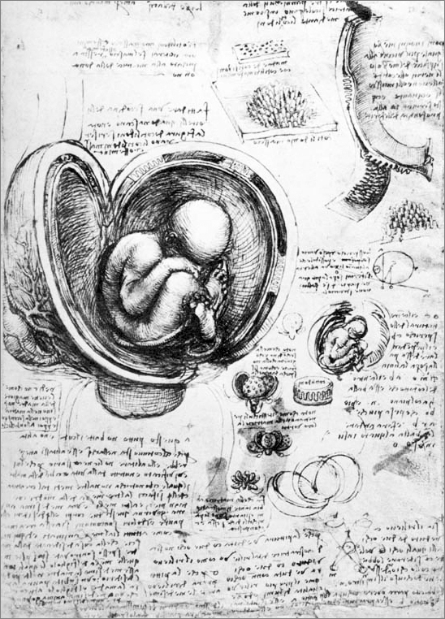

The necessarily constructive character of perception is just as important, then, as the stringent temporal bottleneck of working memory, and, background knowledge is the chief means of overcoming that bottleneck (Cleveland & McGill, 1984; Casner & Larkin, 1989; Carpenter & Shah, 1998; Cook, 2006; Canham & Hegarty, 2010; Hinze et al, 2013). While neither the designer nor the viewer can modify the general time limitation of working memory, both can employ culturally conditioned knowledge-based strategies to minimize its effects and maximize speed of communication.
7 ‘One millimeter equals six thousand men’ – The theoretical significance of Minard’s map
In the many pages that Jacques Bertin devotes to maps in his monumental Semiology of Graphics, nowhere do I find illustration or mention of what Edward Tufte (2006) considers to be the best, most path-breaking map in the history of graphic design: “Carte figurative des pertes successives en hommes de l’Armée Française dans la campagne de Russie 1812-1813”, or “Figurative map of the successive losses in men of the French Army in the Russian campaign of 1812-13”, drawn by the French engineer Charles Minard in 1869.
Why this remarkable omission? One reason may be that Bertin has other fish to fry. The achievement of his 19th century compatriot does not fit into his scheme. Bertin is interested in the “immediate” perceptual effects of definite forms, whereas Minard’s perceptual effects are powerfully mediated by the viewer’s knowledge. Bertin is aware of the temporal dimension of visual perception and its relation to memory. He even points out that ‘a shorter observation time’ makes a graphic construction more efficient. Nonetheless he tends to assign a ‘natural and immediate perception’ to the relationships among the three dimensions X Y Z, and he claims that the viewer’s questions can be answered ‘in a single instant of perception […] IN A SINGLE IMAGE’ (Bertin, 1983: 139, xiv, 146). But all percepts are constructed; none is unmediated. Bertin’s claim is imprecise, or metaphorical, or false. Minard’s map is so clearly mediated by large quantity of relevant background knowledge stored in long-term memory of the viewer that his map is an excellent example of the general cognitive principles enunciated here.
Figure 10: Charles Minard’s map of the Russian campaign of 1812-13. Bibiothèque de l'école nationale des ponts et chaussée, Paris. Dim. 62.4 x 24.5 cm (24.5 x 9.6 inches). Wikimedia Commons, public domain, 2013.
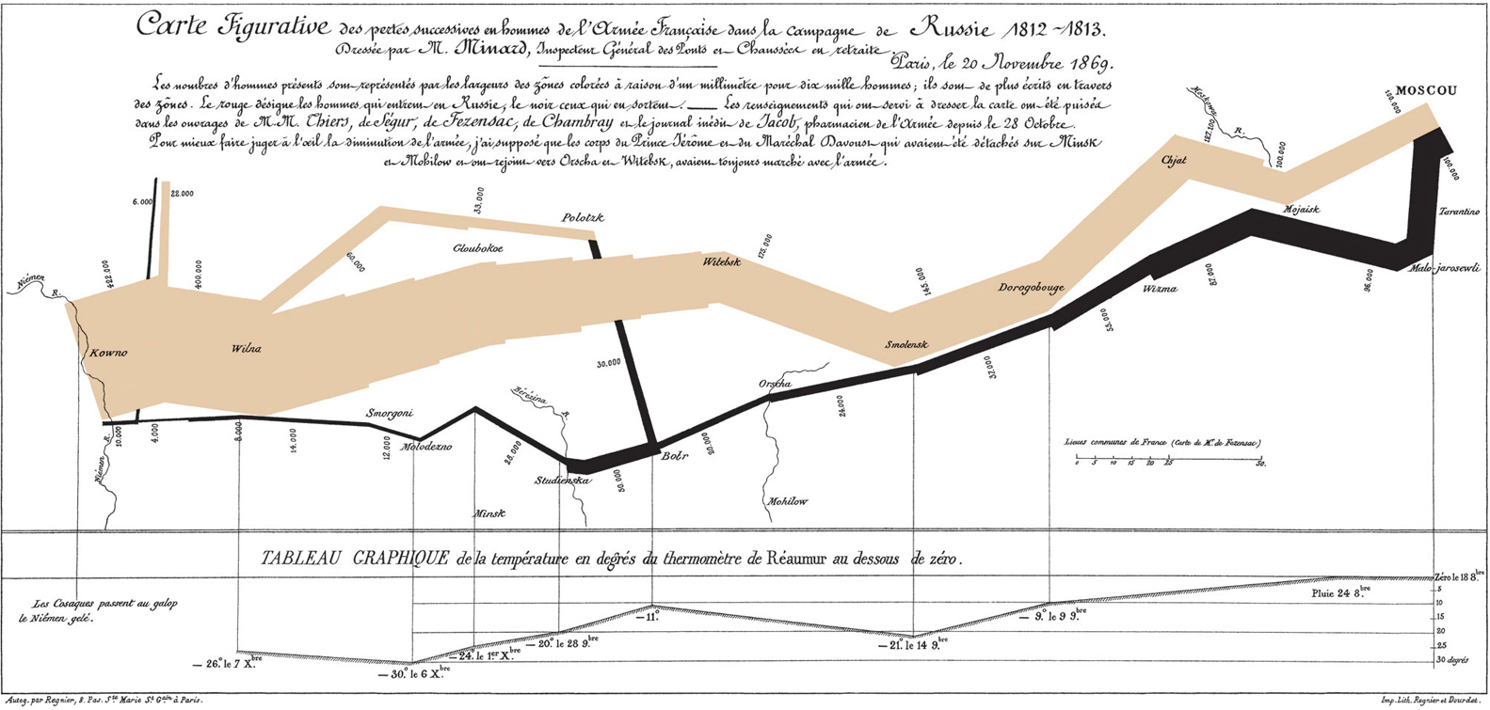

In the diagram of the Russian campaign our normal idea of a map will be challenged immediately because the picture only vaguely resembles a map. And so it will take some time and effort to accept the varying thickness of a path – the colored line – as a statistical representation of the number of soldiers who are still alive at any point in the campaign. But as soon as that visual link between the line (the encoding) and the soldiers (the decoding) is established by the elaborate explanatory label – ‘The number of men present is represented by the size of the colored zones with one millimeter representing six thousand men […]’ (Minard, 1869) – we have no difficulty in sustaining it, and the abstract character of the line is no obstacle to the concrete understanding of the graphic and the appreciation of the story. Yet none of these meanings would come to fruition if the map were presented to a person – say a typical American 4th-grader – who had never heard of Napoleon or the Russian campaign. Minard could assume among his countrymen a tremendous number of associations which make these simple flow lines pregnant with meaning – and emotion!
Of course other means could be used to visualize that numerical variable, but why is this particular device so successful in aiding the viewer to make the connection and understand the graphic? How does the line work as a vivid representation of the data? An ancestor of Minard’s changing line was the bar chart. It was invented by William Playfair and published in London in 1786 in his Commercial and Political Atlas. Minard’s line is at the core a simple bar chart sorted and ordered by value (6K soldiers per mm) from highest to lowest, left to right until it reaches Moscow, and right to left on the journey back.
Figure 11: Minard’s line can be described as a sequence of connected bars aligned at their midpoint.
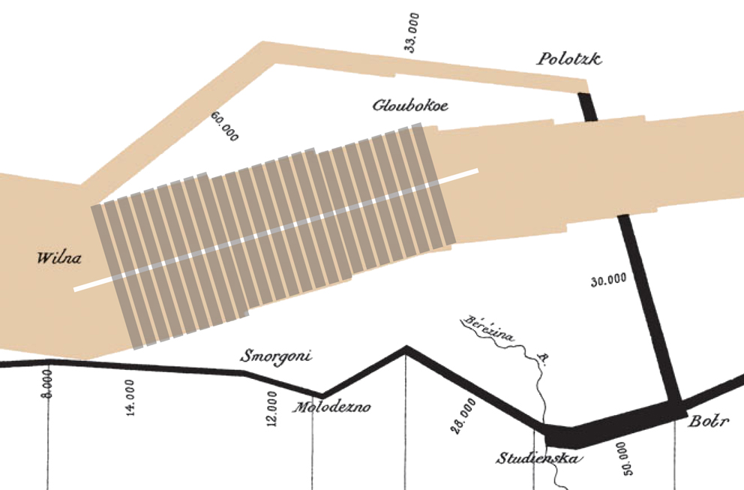

Strictly speaking, the line is formed by a series of bars that have been joined together and aligned at their midpoint – especially in the top portion – instead of at the base, giving the figure its symmetrical, line-like quality (Fig. 11). It was a brilliant technical conception. But the horrific meaning of the graphic remains unseen. Minard’s label, elaborate as it is, could not begin to describe the shared background knowledge, undepicted and unspoken, required to read this famous graphic.
8 The two New York subway maps
Figure 12: New York City subway map, detail, 1972. Massimo Vignelli, designer. Revised: February 1978. Pino Trogu collection.
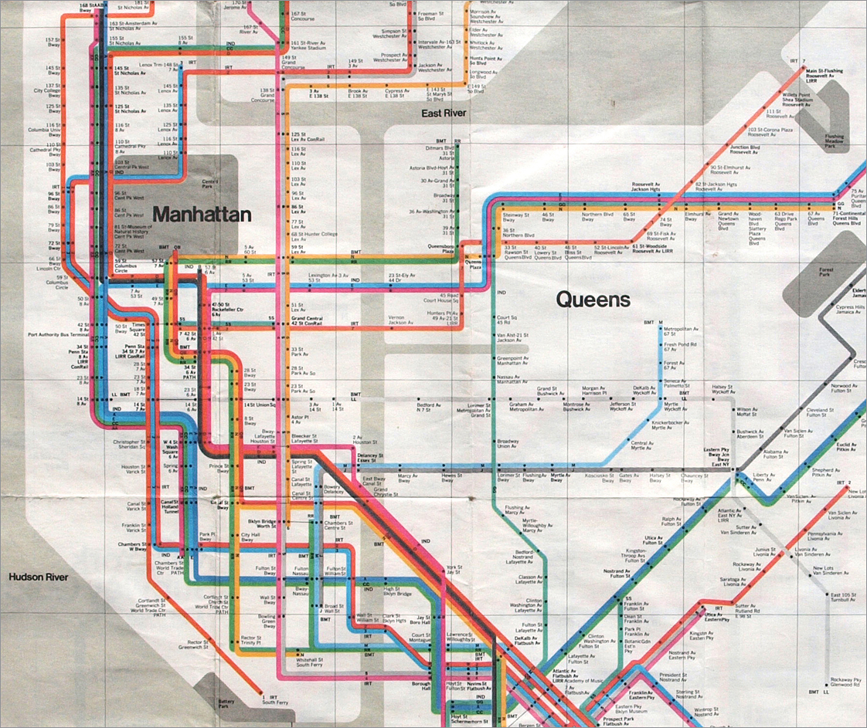

Figure 13: New York City subway map, detail, 1979. Michael Hertz, designer. Revised: Summer 1985. Pino Trogu collection.
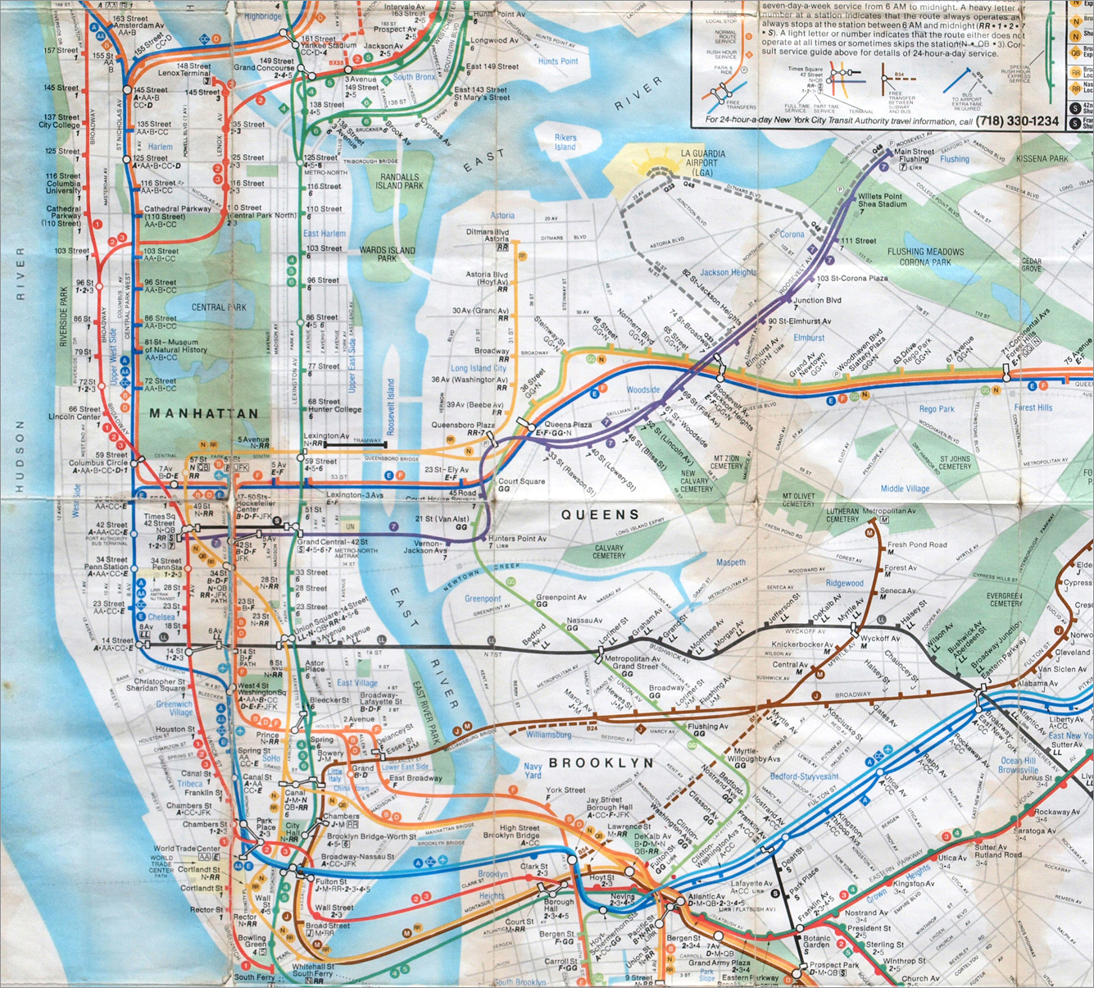

The present New York subway map is an analogical representation of the network of train lines superimposed upon the familiar structure of New York’s streets, parks, and rivers (Fig. 13). Vignelli’s map (Fig. 12) had shown few details beyond the subway system; the replacement map includes all kinds of information: above-ground train lines, tunnels, parks, streets, airports, cemeteries – things belonging to the real world which the average user is trying to navigate.
But ask a three-year old from a small rural town which of these two pictures she prefers, and the answer might well be the abstract Vignelli – depending on whether she likes straight lines rather than curves. And there’s a further subtlety: there’s no principled reason why a schematic representation – more sensitively executed – could not have worked. One could very well make one’s way in New York with a schematic map, just as one does in Paris, whose Metro uses a somewhat similar schematism which like Vignelli’s also emphasizes the rail system rather than the underlying topography (Fig. 14).
Figure 14: Paris metro map. Pino Trogu collection. RATP (Régie autonome des transports parisiens), 2005.
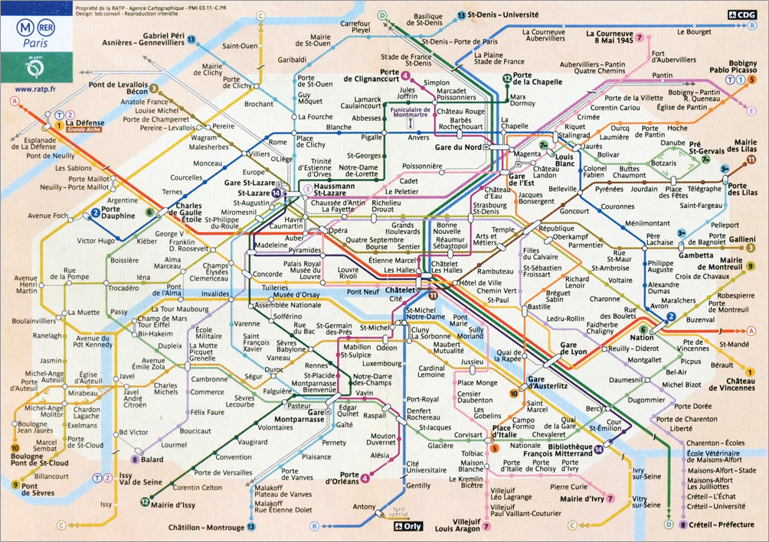

Or in London:
Figure 15: London underground tube map, detail. Pino Trogu collection. Transport for London, 2007.
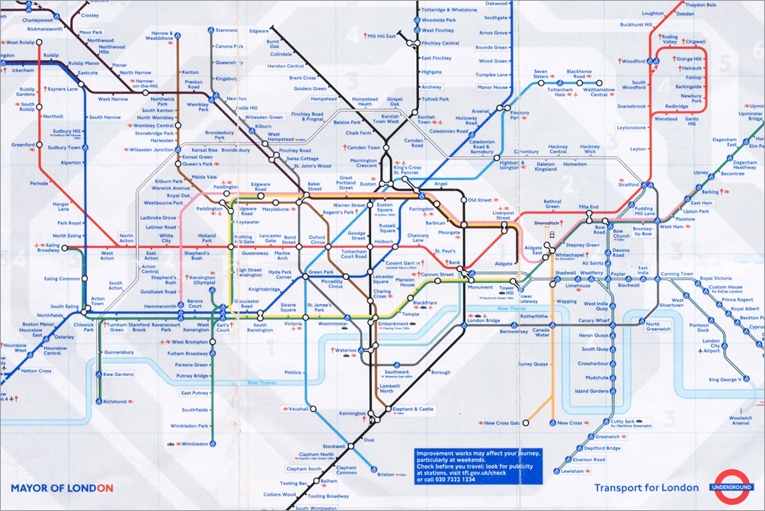

This London map which essentially reproduces Beck’s original design of 1931, is a durable 82 years old and still going strong (Fig. 15).
Why then, did the abstract schematic in London and Paris succeed, while Vignelli’s failed? The basic answer must lie in the way Vignelli thwarted the viewers’ conventional expectations. All maps from Babylon to Google are conventional. For instance, to orient maps northward is a late convention of modern Europe, and earlier in the European Middle Ages, and right up through the Renaissance it was not north but east, (where Jerusalem lay) that was at the top. In fact the very word “orientation” means “pointed to the east.” In China the top was south. To use a map one needs already to know such conventions to orient oneself in space. In a purely river city, like London or Paris surrounded by land, one needs only a schematic representation of the defining river to achieve orientation in real space. If the land area depicted is lengthened or foreshortened here and there to magnify the busy center, the schematic of the river still enables one to feel oriented in space.
New York City is topologically different. Manhattan Island and its surrounding boroughs are far less simple geographically than the river-based topography of Paris and London. And to compound that inherent problem, Vignelli’s version of a schematic representation defies conventional references to topographical reality. He imposes an imaginary white amoeba to represent a very elaborate land complex. Then, only after careful study – long after one has missed one’s subway stop – does one realize that those gray-brown splotches on his map are supposed to be water. This completely overturns the conventional water-is-blue-land-is-brown expectations of his viewers, and further confuses them.
He thus fails to help the viewers orient themselves in space – surely a conventional requirement of a map, going back to the first known maps of Babylonia (Fig. 16) up to the famous Steinberg New Yorker cover. We always read maps looking for a “You Are Here” spot.
Figure 16: Town plan of Nippur, Babylonia, clay tablet, 1300 B.C. The earliest known map drawn to scale. Hilprecht Collection, Friedrich Schiller University Jena, Germany. Redrawing by Pino Trogu, 2013.
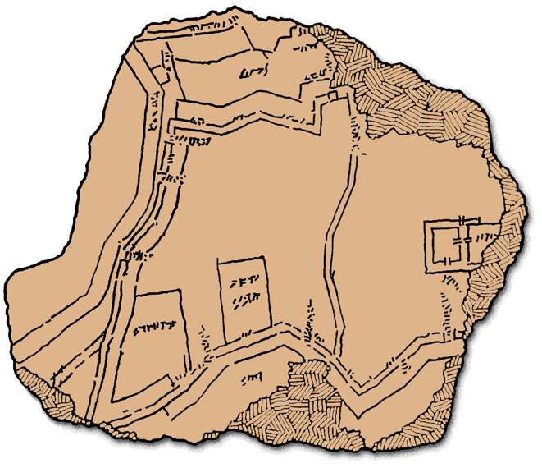

This means that a normal expectation and convention of maps is isomorphism. Any area on the map will have a roughly corresponding area on the earth, with roughly accurate relative magnitude and direction in relation to other represented areas. This convention has been picked up by cognitive-minded industrial designers who termed it natural mapping, and applied it to the intuitive arrangement of control knobs, levers and switches on devices as diverse of stovetops, airplane cockpits, and car doors (Norman, 1988: 75-80).
Figure 17: The control knobs in this stovetop are naturally mapped to the corresponding burners, requiring very little cognitive load to perform the desired action. Illustration by Pino Trogu, based on Norman, 1988.
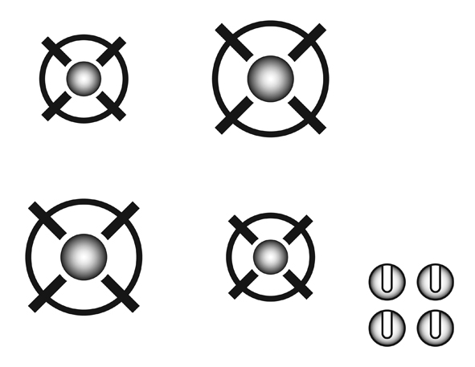

In the London and Paris subway maps this isomorphic relation is stretched, but not abandoned. In the Vignelli map with no detectable water and with Central Park changed from a rectangle to a square, the isomorphic relations are stretched so far that viewers can’t map even approximately or correlate their positions on earth with their imagined positions on the map. New Yorkers were schooled in map conventions, in water being blue, and in their position on earth being related to their position on the subway map. The thwarting of these conventions was bound to induce the confusion the New Yorker’s complained of. They were too knowledgeable; they knew too much about isomorphic map conventions and New York geography, and blue water, and the defeat of their expectations caused massive confusion. To defy those expectations was naïve on Vignelli’s part, and reflected the a-social naiveté of modernism. One could hardly invent a better example of a designer’s failure to meet the primary communicative obligation to work with the conventions, expectations and background knowledge of prospective viewers.
9 Conclusion
Methods and skills alone will never provide a universal recipe for good design. There will never be a formula that will work in all places and all times. Maxims such as “form follows function”, “less is more”, or similar generic statements are equally useful or useless depending on the specific context at hand. Often a beautiful and simple image can be disappointingly uninformative, or an elaborate and complex image can be psychologically simple and beautifully informative.
The cognitive limitations of working memory are always at work in perception and so are the conventional constraints of the viewer’s background knowledge and familiarity with the topic. This process takes place irrespective of the visual style or genre carrying the content. Therefore an awareness of the constraints of cognition, context, and convention should constitute the basis of any methodology which already includes teaching traditional skills such as layout design, typography, and color theory. It should also be the basis for methodologies advocating specific design processes, whether these are “sustainable design,” “design thinking,” “experience based,” or any other recent research directions. In talented hands, good design can and will occur in the absence of a conscious appreciation of psychological processes, but when the general constraints of convention, context, and cognition, are in the designer’s mind, then the practical will successfully reinforce the theoretical and vice-versa.
The Vignelli map offers further interesting support to the principle of historicity. It has made a comeback in an interactive web version called The Weekender (Heller, 2011). Given the interactive nature of this implementation, the spare geometry of the design could be seen as an advantage – especially among a new generation of riders who live in a virtual world, and who may have rather vague preconceptions about the geography around them, and may not have confusion-inducing prejudices about the actual shape of Central Park. Whatever the expectations and conventions of this new generation, and new era, it will be the task of graphic designers to accommodate themselves to those shared assumptions and expectations. For graphic design is not a timeless unconditioned art, any more than “timeless art” is. A graphic design is a cultural, communicative artifact of its own time and place.
Acknowledgement
My heartfelt gratitude goes to E.D. Hirsch, Jr., whose intellectual insight and erudition have guided me throughout the writing of this essay. To him I owe many of the germinating ideas that have been developed into the overall concepts presented here. Whatever clarity I hope to have achieved in this essay, I owe to his many constructive suggestions that followed various critical readings of the manuscript.
References
Full bibliography:
<http://www.trogu.com/Documents/conference/2013_CIDI_recife_brazil/paper>
About the author
Pino Trogu, Assistant Professor of Information Design, San Francisco State University, USA.
<trogu@sfsu.edu>

Hinze et al, 2013. Beyond ball-and-stick: Students’ processing of novel STEM visualizations. Learning and instruction, 26, 12–21. This quote from the abstract: ‘These results indicate adoption and fluent use of visualizations is not given; rather, it is a function of prior knowledge and unfolding experience with presented content.’

