The four-second window: how the time constraint of working memory and other psychological principles determine the success of a graphic design.
Pino TROGU
San Francisco State University
Abstract: This article discusses universal psychological principles derived from cognitive psychology that are useful in creating an effective graphic design. The most important are: the strict constraints of working memory which persists about four seconds, the viewers’ co-construction of perception and meaning based upon their prior relevant background knowledge including their knowledge of culturally constituted design conventions, especially those of genre. If the designer consciously exploits these cognitively and culturally constituted principles the result will be an effective graphic within a specific geographic and temporal context. Better designs are likely to result from familiarity with these principles.
Keywords: working memory, co-construction of meaning, genre, context, inference, design conventions, background knowledge, graphic design, information design, data visualization.

Are there universal principles that determine good graphics? If the question is taken to mean: “Is there a universal practical recipe for creating good graphics,” the answer is “no” because of the cultural contingency of any given graphic with respect to any given audience. The visual form of an image is contingent upon its meaning as interpreted by an audience, as the great iconologists (Panofsky, Gombrich, Wind) have shown. Gombrich, especially, is a useful intellectual forebear of this paper, because of his profound connection with the findings of modern psychology. He rejected as groundless the idea that certain concrete design elements will appeal to all audiences in all times and places; the very form of the design element is never a brute given but a psychological construct—something co-constructed by viewers out of their prior knowledge and expectations. Gombrich made the point very succinctly in explaining the naiveté of the scientists who put a design into the Pioneer Spacecraft meant to communicate something about human civilization for the benefit of beings in outer space who would lack knowledge not only of the represented objects, but also of our conventions of representation (Gombrich 1982, pp. 150-151). For instance, the right side of the woman’s face is narrower than her left. What sort of lopsided creature is that?
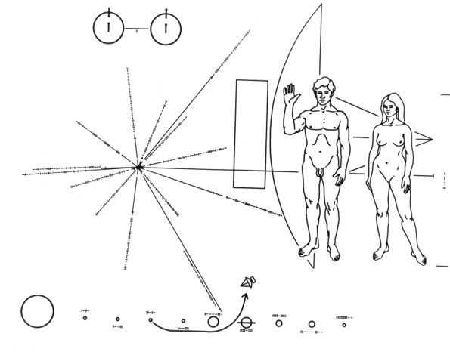
Figure 1. A golden plate with this design was included in the Pioneer 10 Spacecraft launched by NASA in 1972. Source: NASA.
But if the question is understood more modestly “Are there universal principles that determine good, culturally contingent graphics?” then recent cognitive psychology has much to tell us.
In describing how their work is produced and how it is communicated to the viewer, graphic design students and professionals use concrete categories such as form, shape, texture, color, etc. and other abstract categories such as beauty, aesthetics, pleasing, appropriate, etc. A “graphic design work”—“graphic” for short—is considered successful when it achieves its communication goal while achieving at the same time a certain aesthetic level. The beauty of the graphic and its functional effectiveness are two reasons for the success of its communication. While both are important, graphic design students are taught that communication is the number one goal. The main function of graphic design is to communicate, and we cannot escape the old dictum that form follows function. But besides the formal elements of layout, typography, color, etc., which are at the core of both teaching and practice, just what psychological principles enable a graphic to communicate successfully? Recent studies in cognitive psychology indicate that there are indeed some universal principles involved in the perception of a graphic, and they remain the same regardless of styles or modes of design. They are always at work in successful, as well as unsuccessful communications. Moreover, the principles hold for both linguistic and visual experiences: for a book, a poster, a webpage, and whether “Swiss” typography, new wave design, or the latest flavor of visual style is used. Proper knowledge of these principles can help the designer to construct successful visual solutions.
In order to produce graphics that communicate successfully, the designer must realize that the process of communication is fundamentally a psychological process and that the formal aspects of communicative designs are dependent on these underlying psychological principles. These universal principles are neutral with regards to style or form, and they free the designer to select any preferred visual style, as long as the basic psychological requirements are met.

Working memory
In the dialogue between the graphic and the viewer, the most important psychological principle is the time limitation set by working memory, which lasts just a few seconds. “Working memory” is the name given by cognitivists to that short time span during which the human mind can put experiences together to form a meaning lodged in long-term memory. Understanding this very stringent bottleneck of the mind has been one of the greatest insights of psychology since the 1950s, when George A. Miller published his famous article: “The magical number seven, plus or minus two: some limits on our capacity for processing information.” (Miller 1956) The current view sees the limitation as mainly a time constraint—a window of just three or four seconds. Within those first few seconds, if the viewer is not able to “construct” the various elements into a broader meaningful whole that is sent to long-term memory, then some of those elements will quickly drop from working memory, and little that is meaningful will survive.
Because of this limitation of working memory, insuring a very short processing time is critical to the designer. Within this window of time, a meaningful whole must emerge from the various elements. The viewer can repeat the process for various subgroups of elements, but in every case has to reach meaningful closure. A similar sub-process takes place in language, where the clause, which is now considered to be the primary unit of speech, is a universal feature of all languages. (Hirsch 1977, pp. 108-109)
In order for the viewer to be able to reach fast closure, within a few seconds, the designer has to make the elements of the graphic work quickly in concert. But this limitation need not apply to the whole graphic all at once. Just as a good book, or a beautiful speech can successfully communicate to the reader or listener by virtue of a succession of well-defined primary units like clauses and other subunits, a good overall graphic can be comprehended as a series of meaningful visual units that have reached “closure”, each comprised of several smaller component elements.
Furthermore, in a visual work, the primary units may not necessarily be perceived in a fixed and specific sequence of time. For example, a good transportation map works well as a meaningful overall image, but its more practical use is in obtaining local, detailed step-by-step instructions related to some sub-portion of the whole: a specific route, a specific neighborhood. Because of the various settings and time frames in which graphics can be used in a practical way, individual graphic design problems require individual ad-hoc solutions. Thus, a theory of graphic design is not a fixed set of universal formal principles, but instead it must rely on a set of underlying universal psychological principles—especially the universal limitation of human working memory.

Co-construction of meaning
Until the graphic is interpreted by the viewer, it really isn’t a meaningful graphic at all: “The formal features of any design do not precede but follow the interpretation of that form.” (E.D. Hirsch, Jr., pers. comm.) In the interpretation process, the viewer brings to bear a complex system of expectations comprised of past experiences. Hence, in addition to the time limitation imposed by working memory, a second universal psychological principle in any visual or linguistic communication is that of the co-production of meaning by the viewer. Modern psychology tells us that perceiving and remembering are both productive acts based on past experience—an important insight that psychology has reconfirmed many times since the path-breaking book by F. C. Bartlett: Remembering: a study in experimental and social psychology (1932). Bartlett included the idea of the socially shared expectations as part of the remembered event. The art of creating an effective graphic involves the successful social prediction by the designer of the kind of response the typical viewer will probably construct. Just as memory is not the passive reproduction of past events, but rather an active productive process, the experience of the graphic is not a passive activity but a productive one based on relevant past experiences by the viewer.
The two principles of working memory and the collaborative co-construction of meaning are always interacting. In the communication, if the viewer is familiar with the subject matter, closure will occur much faster. Therefore it is important for the designer to include in the graphic the most appropriate and relevant information, instead of assuming that the viewer already has this information. The limitations of working memory can be reduced in large measure if the background knowledge brought in by the viewer is both highly familiar and relevant to the subject matter at hand.
Two maps from the US presidential election in 2008 illustrate the importance of background knowledge in the interpretation of a graphic. Someone not familiar with the electoral college system might be puzzled by the predominance of the red color in the map in Fig. 2, showing the counties that went Republican in an election that was actually won by Democrats (The New York Times 2008).

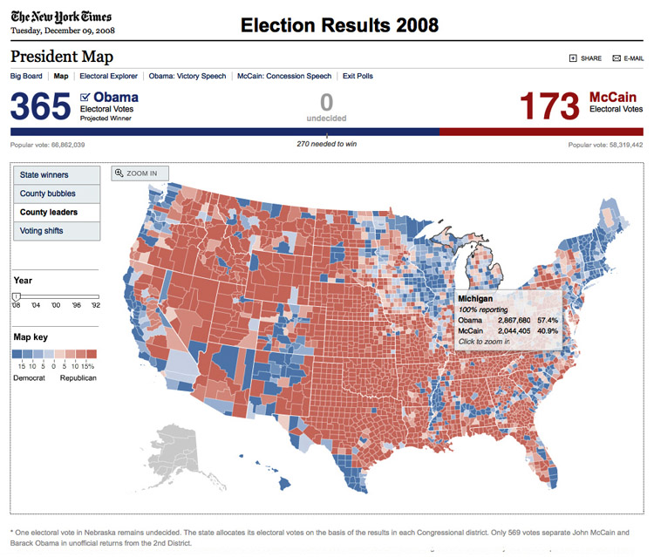
Figure 2. US Presidential Election 2008. The map shows counties won by McCain (red) and by Obama (blue). Source: The New York Times, 2012.
In the stylized map in Fig. 3, the states are sized according to the number of electoral votes for each state (Nagourney, Zeleny, et al. 2008). This more abstract map reflects the “winner take all” system of American elections, where a single extra vote at the state level means that all “votes” for that state go to the winner, and none go to the loser.
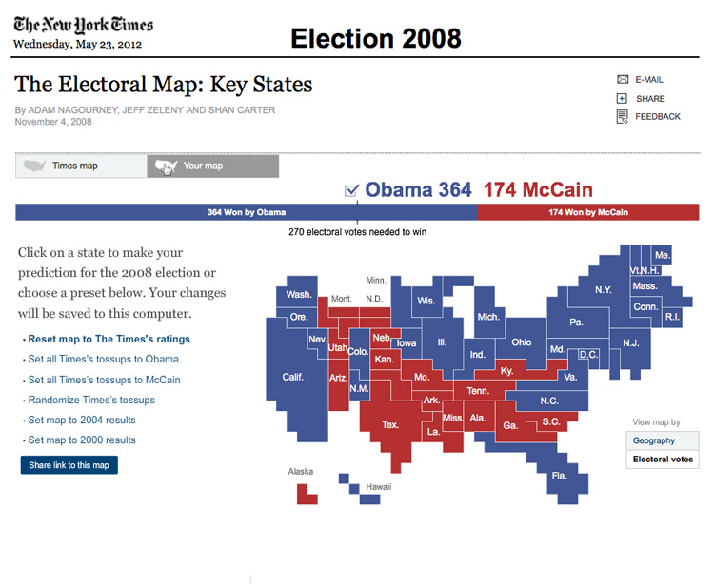
Figure 3. This map (cartogram) shows the states that each candidate won in 2008. States are sized proportionally to the number of electoral votes. Final count was: Obama 365; McCain 173. Source: The New York Times, 2012.

Design conventions
In this exchange between designer and viewer, design conventions play a critical role. Just as there exists a set of conventions in spoken and written languages, design has its own set of visual conventions. It’s a mistake to assume that the viewer will be automatically familiar with the design conventions that the designer employs. But because all verbal and visual communication is based on prior agreement on a set of conventions, the effective designer has to work within the constraints of conventions that are familiar and in effect in a given cultural moment. A visual element that might mean one thing in Europe might mean something completely different in Australia. Sometimes this applies to basic categories which would seem at first to have a natural fixed meaning, for example: up is good, down is bad, the white color means life while the black color equals death, etc.
We learn from anthropology that while black may have a negative value and white a positive one in one tribe, the reverse may be the case in another tribe; and the same may hold for numerous design elements. No doubt some elements are trans-cultural: the female body, an infant’s face, but the safest course is to assume that all design elements are dependent for their effectiveness on the culturally-constituted assumptions and expectations of the viewers.

Genre and context
As Bartlett pointed out, the act of remembering, as well as perceiving, is not a mere reproduction of a past experience, but rather a re-construction of the experience based on typical features of other events of the same type experienced over time. When looking at the front page of a newspaper for example, we prepare to read it based on how we read it in previous instances. We expect to see titles at the top with text immediately below them. We expect all columns of text under a title to belong to the same article, and so on. These expectations, if properly fulfilled, contribute to the re-construction of the object “newspaper” as we know it. We recognize the object newspaper as belonging to a similar type, or “genre” as we have experienced it in the past. The recognition of genre takes place within the narrow window of working memory: three-four seconds, and the positive feedback of an object that matches our past experience of similar objects, lets us move forward to actually read the articles in the paper.
Imagine a situation in which the visual elements and the typographic conventions of titles, subtitles, etc., were to be disrupted or omitted. Imagine the articles having no titles. Looking at such object, the typical reader of The New York Times today would be puzzled and wonder if he were holding a real copy of the paper or a fake. He would not recognize the paper as he has come to expect it to look based on his prior experiences. The genre and type would not be determined within the four-second window and communication would be compromised. Genre and type are not absolutes though, but function within the social conventions of a given cultural time. This is the social dimension and perception pointed out by Bartlett: the viewer must share in the system of values and conventions within the specific historical context if he is to understand the specific genre and types presented to him at that given moment.
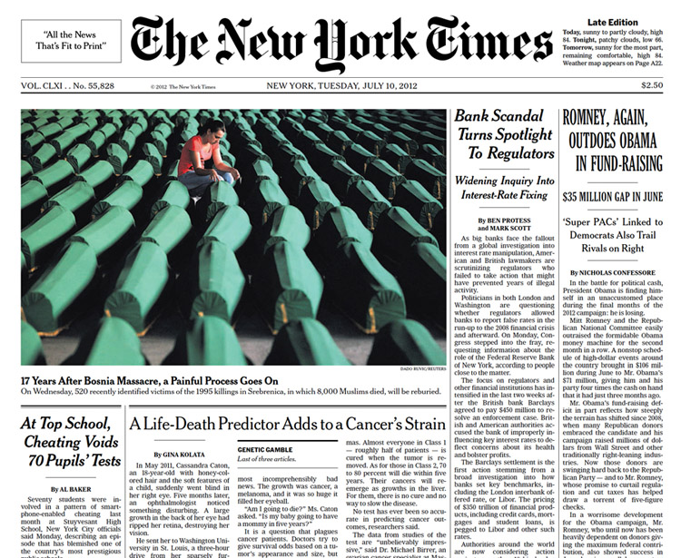
Figure 4. Front page of The New York Times. July 10, 2012. Detail. Source: The New York Times, 2012.
One of the first readers of The New York Times, which started publication on September 18, 1851, might be forgiven for feeling disoriented if he were to travel forward in time more than 150 years and be given a copy of the same paper from 2012. What would he make of the extensive use of relatively large titles, subtitles, and above all, color pictures? He would have been familiar with newspapers that densely pack the text, use minimal titles and display no pictures at all. The first issue of the paper, initially named New York Daily Times, employs just these graphic conventions, which were typical of newspaper publishing at the time of its debut in the middle of the 19th Century in America.
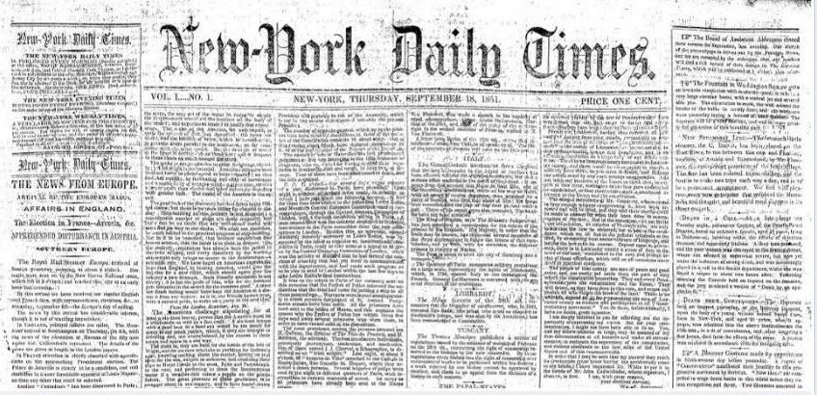
Figure 5. Front page of the New York Daily Times, later renamed The New York Times. First issue, September 18, 1851. Detail. Source: The New York Times, 2012.
The New York Times example demonstrates that one of the most important tasks for the designer is to make sure to include in the graphic those elements that help a viewer quickly place the object in the right context. This means allowing the viewer to immediately identify the correct genre or type. Only after the type or genre is identified, can the reader start making meaningful constructions and make sense of the whole. The designer needs not only to provide the elements necessary for correctly identifying the genre but he also must make sure to exclude those elements that might be misleading and steer the viewer in the wrong direction. Because visual elements and verbal text are not absolutes but can vary in the meaning they convey and they can be ambiguous, the designer must clear this ambiguity right from the start at the higher level of titles, subtitles, and large images. Good titles and other means of quick orientation as to type or genre, within the four-second window, are a must in any graphic that does not want to lose its reader, who will quickly move on unless his attention is drawn in effectively. Proper initial orientation is akin to the role played in a good map by the “You Are Here” mark. The mark quickly establishes the spatial relation of the viewer to its surroundings. In a graphic, the elements that properly identify the type or genre help the viewer to quickly place that graphic into the larger, correct social context. Once this contextualization takes place, the viewer can then process the secondary elements in the graphic much more quickly.
It should be noted that in specific instances, the designer might choose to mix-up genres intentionally, in order to create a sense of initial displacement in the viewer, only to reward him more emphatically later, when the true meaning of the graphic is grasped. And so he might elect to design an annual report that looks like a comic book, or a DVD package that looks and feels like a jewelry box. Here he might play with irony and visual puns, and use tongue-in-cheek devices aimed at particular audiences. He can do so thanks to the inherent ambiguity of language and visual expression. While this is obviously a fertile area of exploration for the designer, this paper focuses more on those means that the designer will explicitly make clear to his audience, in order to avoid as much ambiguity as possible. This approach should be the norm in the fields of information graphics and data visualization. Here clear and direct communication is the main goal. This field includes maps, diagrams, and the display of large and complex sets of information.

Inference and construction of meaning
Just like remembering and recall, perception is characterized by an act of construction in which the viewer brings to the interaction much more than is explicitly given in the text or visual presentation. The viewer constructs a perceptual object that is much richer than the immediate physical stimulus of the graphic. A typical example of this constructive feature of perceiving is the act of looking at familiar two-dimensional objects. When a viewer looks straight at the facade of a building, he sees only that one side, but he nevertheless perceives a three-dimensional object with a definite solid character. He does so because he knows from experience that a building must have sides and a back in addition to the front. (Hirsch 1967, p. 132) The same thing happens in perception when a reader reads a text or experiences a visual representation. In both activities he has to construct stuff that is not explicitly given in the text or the graphic. He has to infer a lot of things in addition to what he actually sees, in order to make sense of it. We make references and put things into context all the time, and we do it without specific instructions because this process is inherent in language and perception since infancy.
So the first thing that needs to happen in the initial 3-4 seconds of the viewer’s interaction with the graphic is a kind of “genre check”, a self-posed question-and-answer that might yield a response similar to: “This is a building; it must have other sides.” As mentioned, good titles, as well as other means of self-orientation, both typographical and pictorial, are therefore critical for paving the way to further exploration on the part of the viewer, otherwise he will be puzzled and discouraged from the very onset of the interaction.
The New York Times provides a good example where all the initial elements contribute to “getting off to a good start” by their expert arrangement and calibration. From the subtle typographic elegance and legibility of the typefaces, to the concise and no-nonsense style of the titles and subtitles, to the counterpoint usage of pictures, captions and other small details such as author bylines, and finally to the overall layout that reinforces the reader’s expectation of consistency and habit, everything on the page contributes to an interactive experience that is immediately clear and fulfilling.

The annotation layer
It’s seldom that graphics consist only of just text or just pictures, although the latter is more likely to need the former in more cases than the other way around. It’s true that often “a picture is worth a thousand words”, but it’s also true that often a graphic that does not provide enough textual support runs the risk of being misunderstood and misinterpreted. In the powerful interplay between image and text that occurs in a graphic, this task of providing enough textual information is often neglected. In graphics, the addition of text to the visual elements can make the graphic truly informative. Amanda Cox, graphics editor of the New York Times, stresses the importance of the “annotation layer”—the written text—in successful data visualization. She states: “We learn by connecting to what we already know.” (Cox 2012) She proves her point with a simple exercise performed on the front page of The New York Times (paper edition) in which she highlights things that she does not already know. The extent of “unknown” facts amounts for her to only about ten percent, every day during a typical week.
Based on this simple fact, most formal constructions, however sophisticated, must yield to the realization that a graphic is highly influenced by the relevant background knowledge of the viewer. New knowledge is best communicated by a graphic that combines new elements with past familiar elements. Brief notes, legends, captions, etc. are therefore an excellent way of providing the viewer with general background knowledge upon which new knowledge can be built.
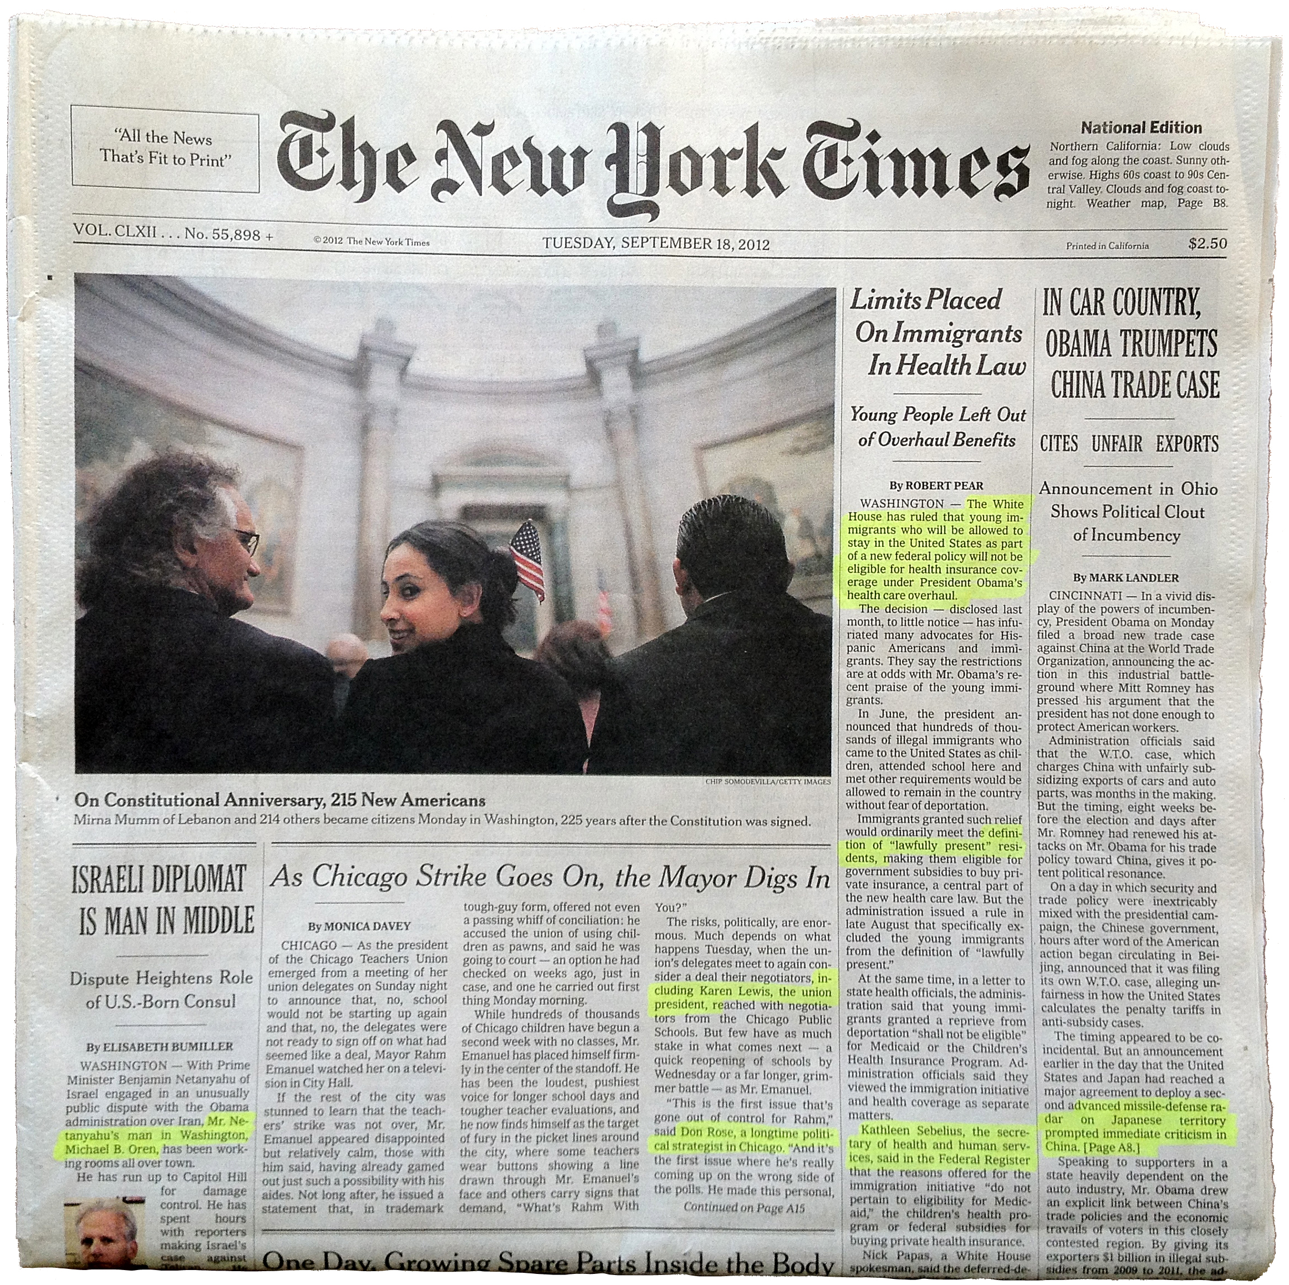
Figure 6. Front page of The New York Times, detail. The highlighting shows new knowledge acquired that day. Replica of original exercise presented by Amanda Cox. Source: Author, 2012.
This annotation technique can be seen to work effectively in a graphic about driving safety, published recently in The New York Times (Fairfield 2012), which depicts the decline in traffic fatalities in the US in recent decades (Fig. 7). In the graphic, a segmented line connects various dots representing the years from 1950 to 2011. Each dot’s position is determined by the number of miles driven per capita in that year (x axis) and by the number of fatalities per 100,000 people in that year (y axis). The title of the piece: “Driving safety, in fits and starts” sets the tone for the other textual and visual elements.
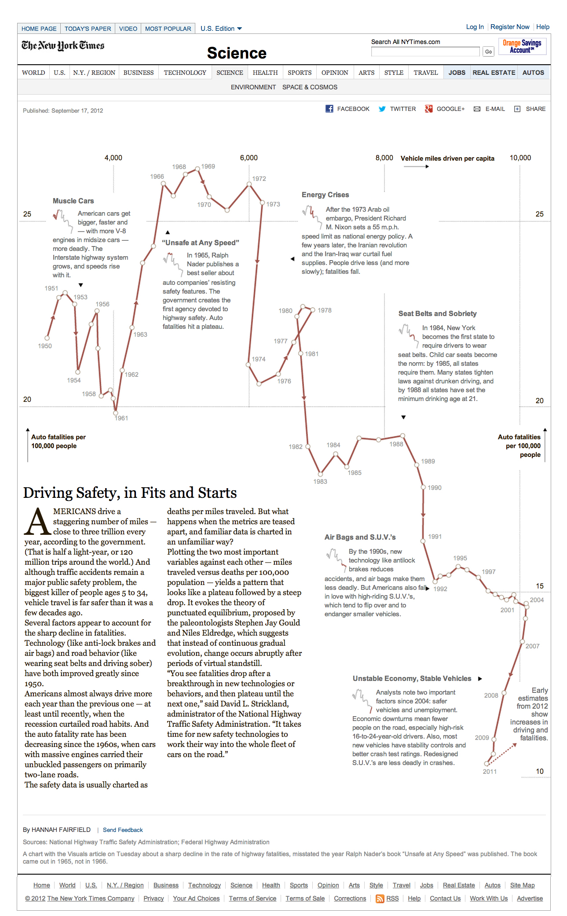
Figure 7. Driving safety, in fits and starts. The New York Times, September 17, 2012. Source: The New York Times, 2012.
Various sections of the line are described in detail with smaller chunks of text and smaller views of the described sections that function like a legend. The economy of means of this graph: clean lines and legible typography, combined with concise and clear text, make for a well-sequenced and informative piece. Despite the large amount and relative complexity of the data, the viewer is able to absorb the parts and quickly move from overview to detailed description. All visual and verbal elements provide for fast closure, despite the relatively long time commitment on the part of the viewer to read the graphic in its entirety.

Ad-Hoc design
Most graphics display aesthetic and communicative values for particular audiences at specific times, and so it should be stressed that every graphic is an ad-hoc construction, although this is not in contradiction to the general implications and validity of the psychological principles mentioned earlier.
In the making of a graphic, a failure to account for working memory, closure, co-construction of meaning, background knowledge, and shared conventions, often results in poor, uninformative pieces. Practical effects of this oversight are sometimes extreme simplification, overload of elements, lack of a specific sequence for reading the elements, or a false parallelism between simplicity of form and simplicity of communication and interpretation. This false parallelism shows up in a famous historical artifact: the 1972 New York subway map (Challand 2010), which displays a cheerful and yet impractical formal beauty (Fig. 8).
The map was much admired by fellow designers despite its failures as a practical way-finding tool for the average user of the subway. In this classic example, the arbitrary geometry of its square format actually works directly against the physical observations of the subway rider: he cannot easily match the stretched distances and distorted proportions of the map with the reality and the precise topography of the city above the ground. Since 1979, the geometric map has been substituted with a more “topographic” map and has remained fundamentally unchanged since then (Fig. 9).

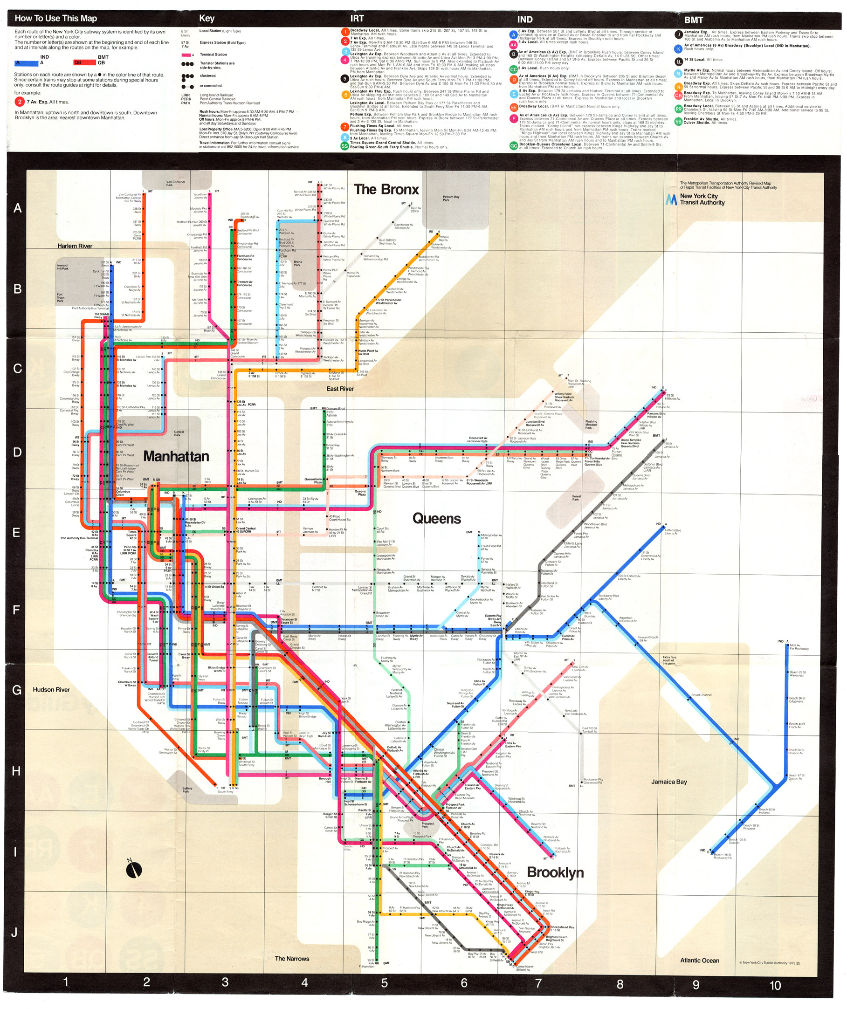
Figure 8. The New York Subway map designed by Massimo Vignelli in 1972. Source: Author, 2012.
Figure 9. The New York Subway map from 2012, based of the 1979 redesign by Michael Hertz. Source: MTA, New York City, 2012.
￼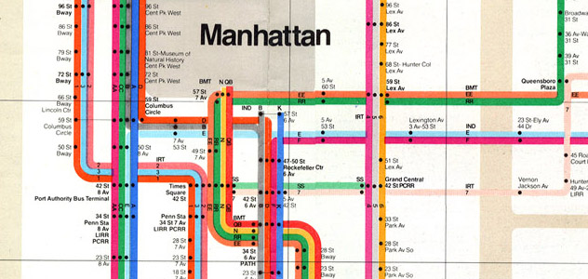
Figure 10. Detail of New York Subway map from 1972. Source: Author, 2012.
Figure 11. Detail of New York Subway map from 2012. Notice how, compared to this map, the 1972 map stretches the topography horizontally. The two details represent approximately the same geographic area. Source: MTA, New York City, 2012.
In another example related to transportation, an underground electronic board that displays train schedule information in the MUNI public transit system in San Francisco, is another stark example of lack of closure and disregard for the viewer’s past knowledge and habits. In this board, a highly schematic map of the system offers very little useful information. Next to the map, a table of train arrival times seems at first glance to provide all the information that is needed. Alas, the list of trains and their letter symbols is statically sorted in alphabetical order, with constantly changing “times to arrival” information located next to each train (Fig. 12). A typical viewer might expect, based for instance on prior travel experiences (airports, train stations, etc.) that the train listed at the top would be the next train coming into the station. Such is the case with departure and arrival tables on display in airports around the world (Fig. 13). The uninformative alphabetical sorting, coupled with the vague “inbound” and “outbound” headers make for a very confusing graphic, especially for first-time users.

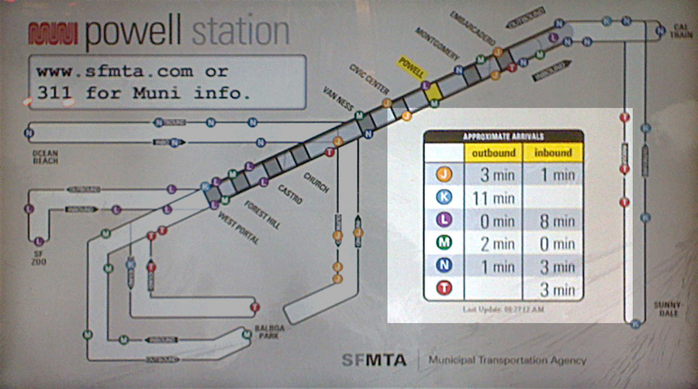
Figure 12. MUNI public transit system, San Francisco. This electronic board displays the map of the system and a table of “times to arrival” of trains. The detail with the alphabetically ordered table with arrival times has been highlighted for clarity. Source: Author, 2012.
Figure 13. Departure table for flights leaving San Francisco International Airport. Screen shot from Airport Remote app for smart phone. Flight information is sorted by time, with the next flight at the top of the list. Source: Author, 2012.
An example of misguided parallelism between “geographic maps” and “abstract conceptual maps” can be seen in graphics that mimic traditional road maps for the purpose of highlighting the relationships between elements in an abstract system. However, while traditional maps bear a direct, natural connection to the physical objects that they represent: roads, cities, rivers, etc., in these diagrams the subject matter is often a set of abstract concepts that lack a given “natural arrangement”. The “concept map”, popularized by Joseph Novak and Bob Gowin in their book Learning how to learn, (Novak & Gowin 1984) claims to be analogous to a road map, but is in fact a visual abstraction that merely lists the items in the system and connects them with other items by means of more words or lines. In concept maps, the absolute limit of the number of items we can focus our attention on at any given time (Miller 1956), as well as the stringent time limitation of working memory, play against the purposed insights to be gained by the spatial arrangement. Instead of remembering and retrieving the concepts, the viewer tends to retain the purely visual abstract image, without retaining the concepts or the main content. The skeptical readers might want to test their retention rate after examining the following example, included in an article about the theory and construction of concept maps (Novak & Cañas 2008).
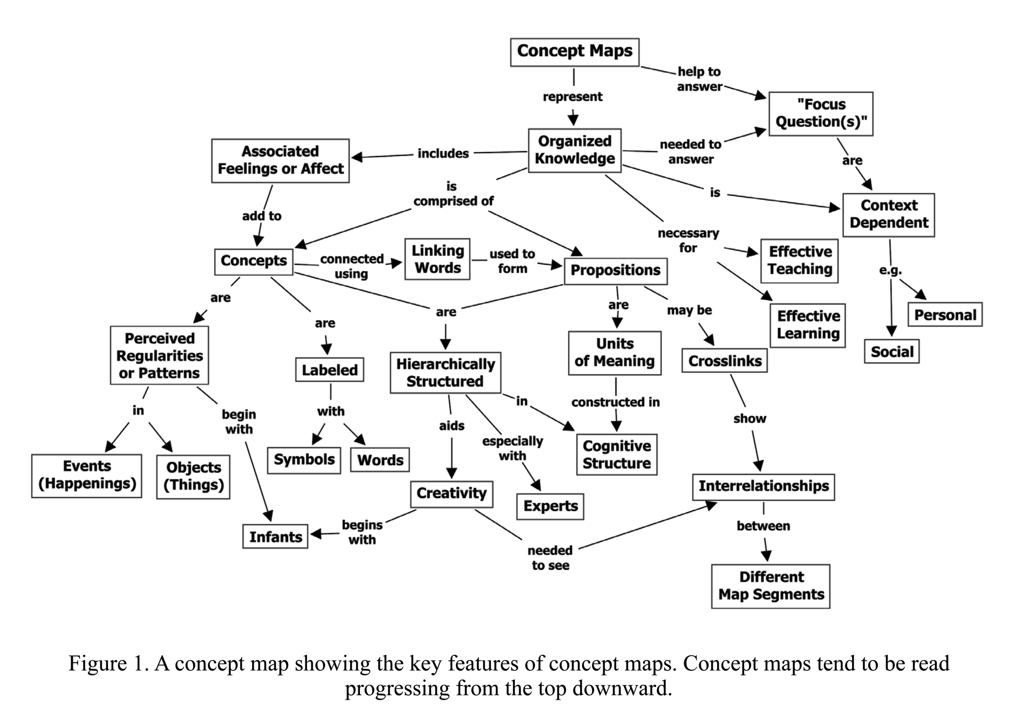
Figure 14. A “self-referential” concept map showing the key features of concept maps. Source: Novak & Gowin, 1984.
An illustration about the American Military strategy in Afghanistan pulls all the stops in the lack of concern about absolute quantitative limitations as well as working memory limitations of the viewer. This last example, first uncovered by NBC (Engel 2009) and republished by The New York Times (Bumiller 2010), demonstrates that sometimes verbal, written text by itself, could be much more effective than a confusing and cluttered image with no focus or meaningful sequence.

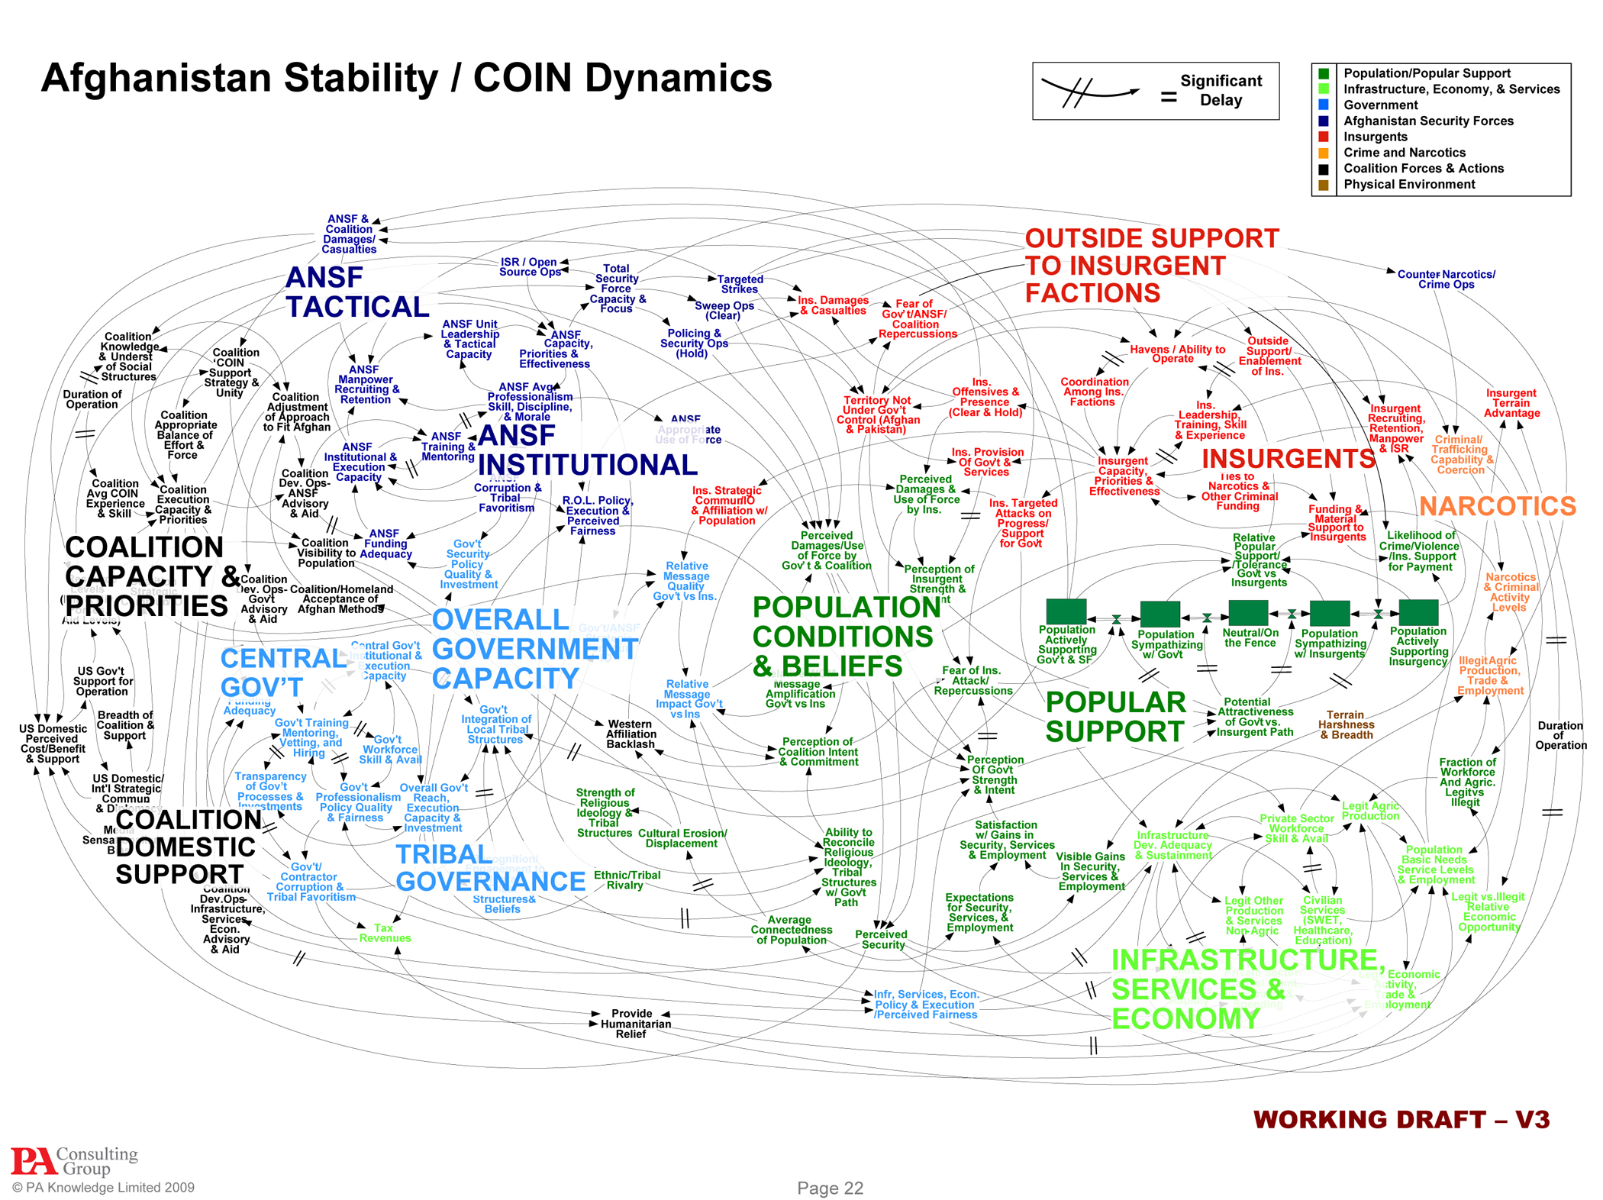
Figure 15. Diagram from “Dynamic planning for COIN in Afghanistan” an unclassified document from the Office of the Joint Chiefs of Staff, detailing the US counterinsurgency strategy in 2009. Presented as a projected PowerPoint slide. Source: PA Consulting Group, 2009.
The road map model is also on display in a recent typographic illustration from TIME magazine about the 2012 London Olympics (Cooke, Gibson, et al. 2012). In this example, there is no pretense of assigning specific meaning to the colorful lines containing the text. The lines are simply there to evoke the lines of the London underground subway map, provided that one has seen the original map before. Here, it’s up to the endurance of the reader to try to read all the zigzagging text crammed inside the colored lines, without getting frustrated and ending up with a stiff neck.
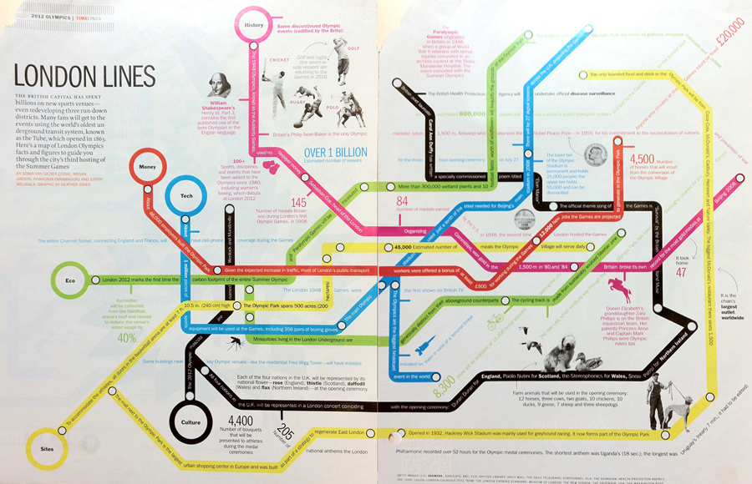
Figure 16. London lines. Article and infographic on the 2012 London Olympics. TIME magazine, July 30, 2012. Spread size: 16 x 10.5 inches. Source: Time magazine, 2012.
In the same issue of Time, another illustration on Olympic trivia (Adams, Cooke, et al. 2012), while still rather busy, manages to do a much better job at breaking down the information into smaller, finite chunks of text that can be read more easily and sequentially.
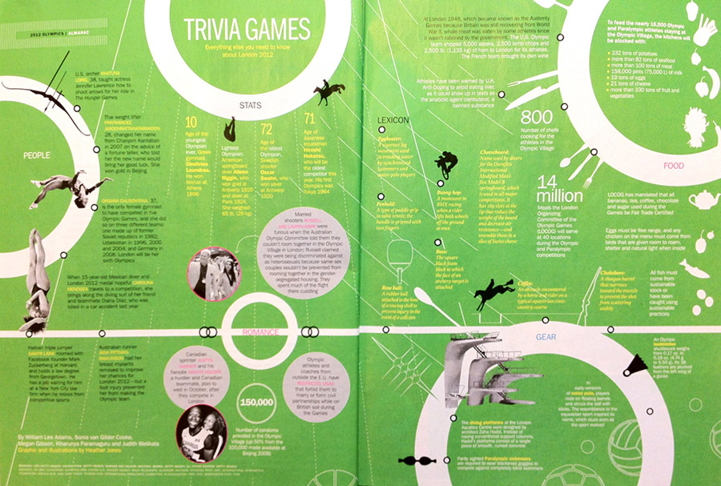
Figure 17. Trivia games. Article and graphic in TIME magazine, July 30, 2012. Spread size: 16 x 10.5 inches. Source: Time magazine, 2012.

Applying the theory to design practice
From the start, a successful graphic must communicate accurately to the viewer the genre to which it belongs. What is the type of graphic that we are looking at? If this question is not answered within the first four seconds of the interaction, the viewer will have trouble focusing his attention on the piece. Sometimes that window can be reopened and one will need to “restart”, but more often than not he will get frustrated and he will refocus his attention on something else.
A look at two information design posters by students in my information design class, will help to clarify this principle. The first poster (poster #1) addresses the topic of team payrolls in Major League Baseball in the US. The second poster (poster #2) presents the topic of the world’s tallest buildings.
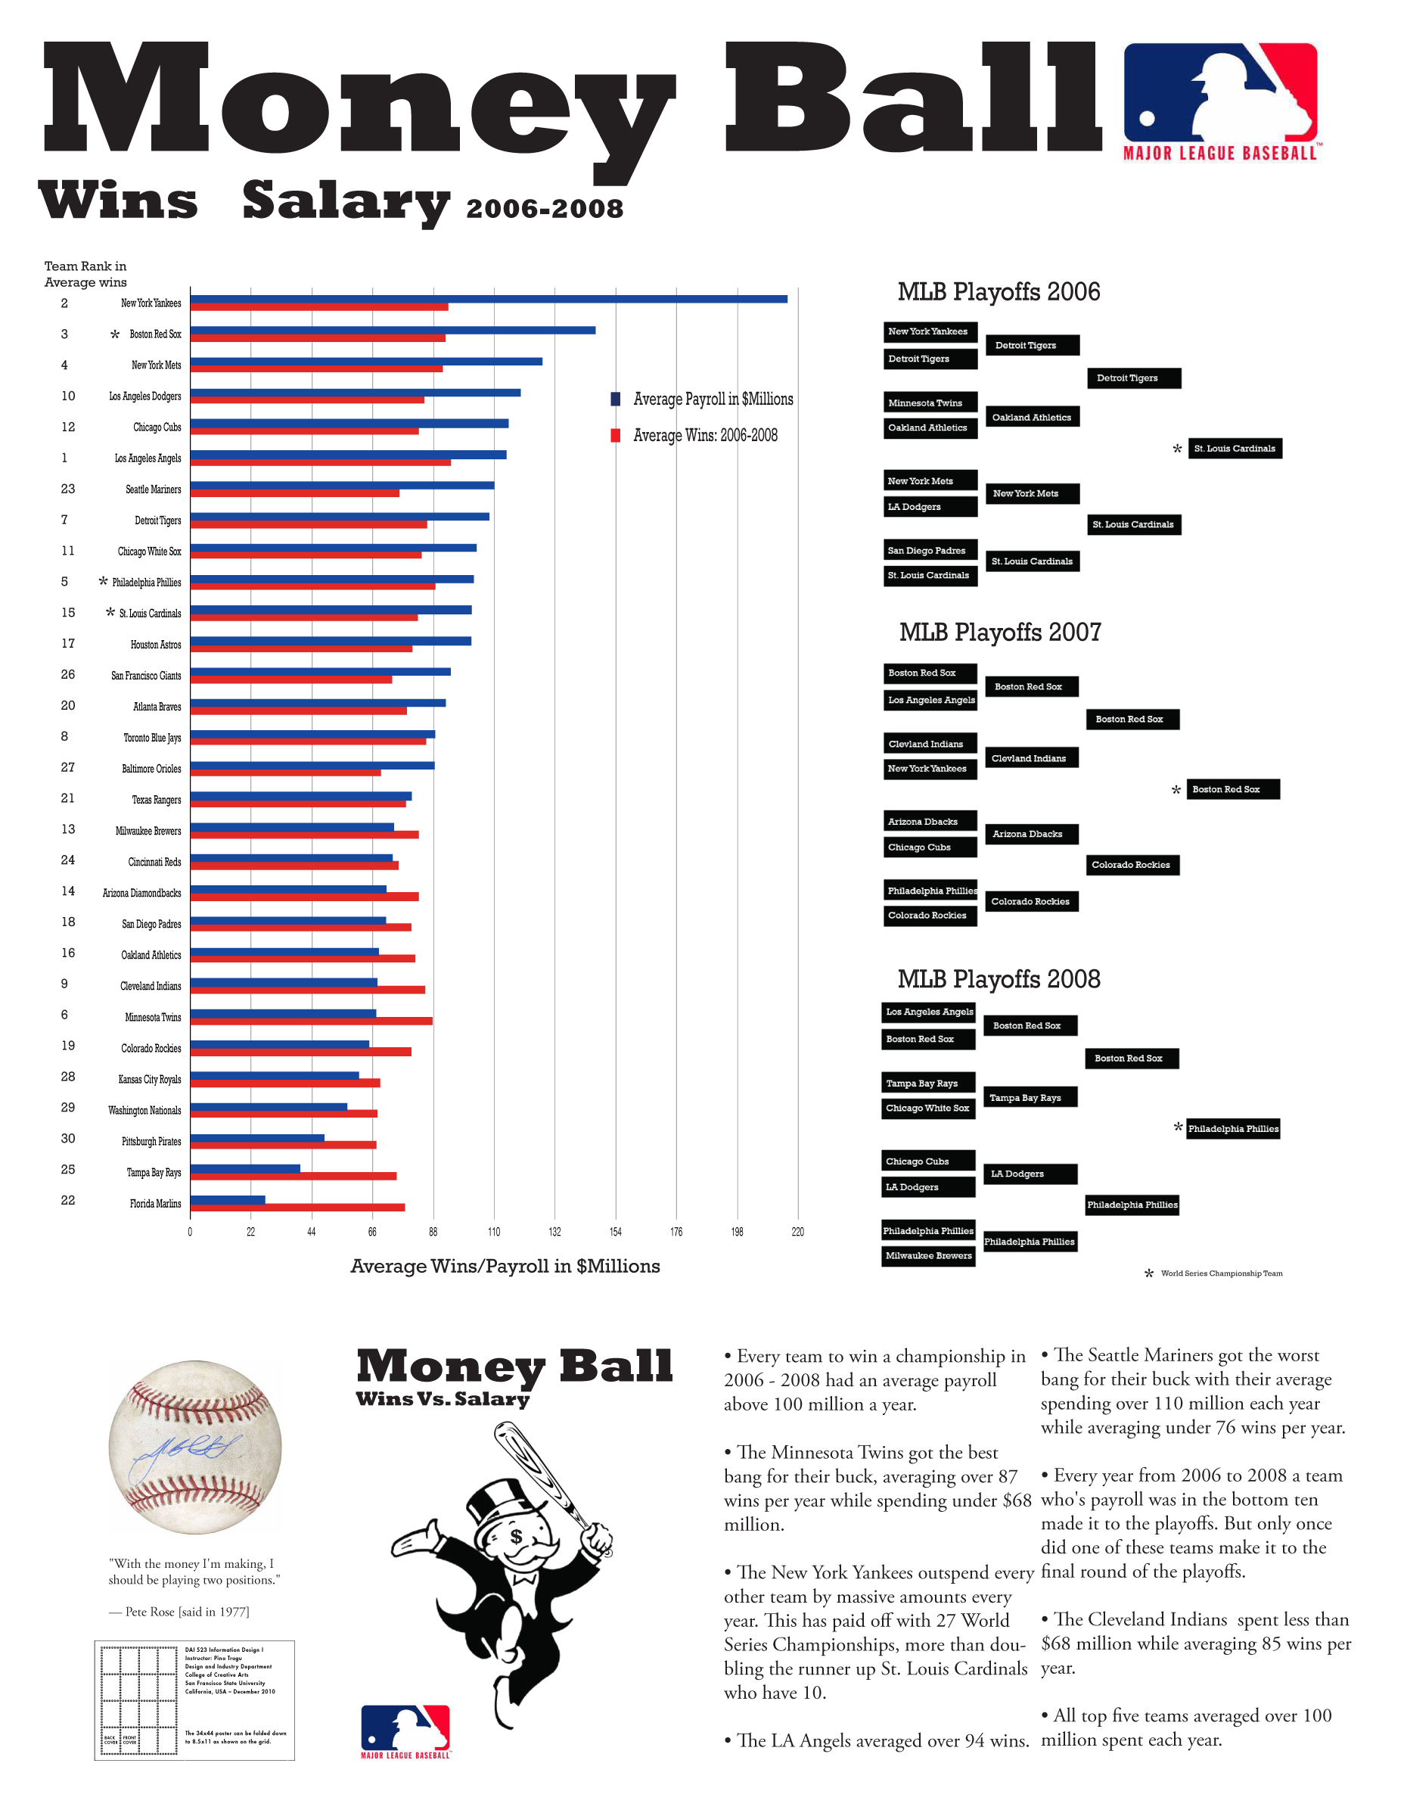
Figure 18. Student poster (#1) on the relationship between payroll and performance for teams in Major League Baseball from 2006 to 2008. Poster size: 34 x 44 inches. Source: Author, (student work: A.N.) 2010.
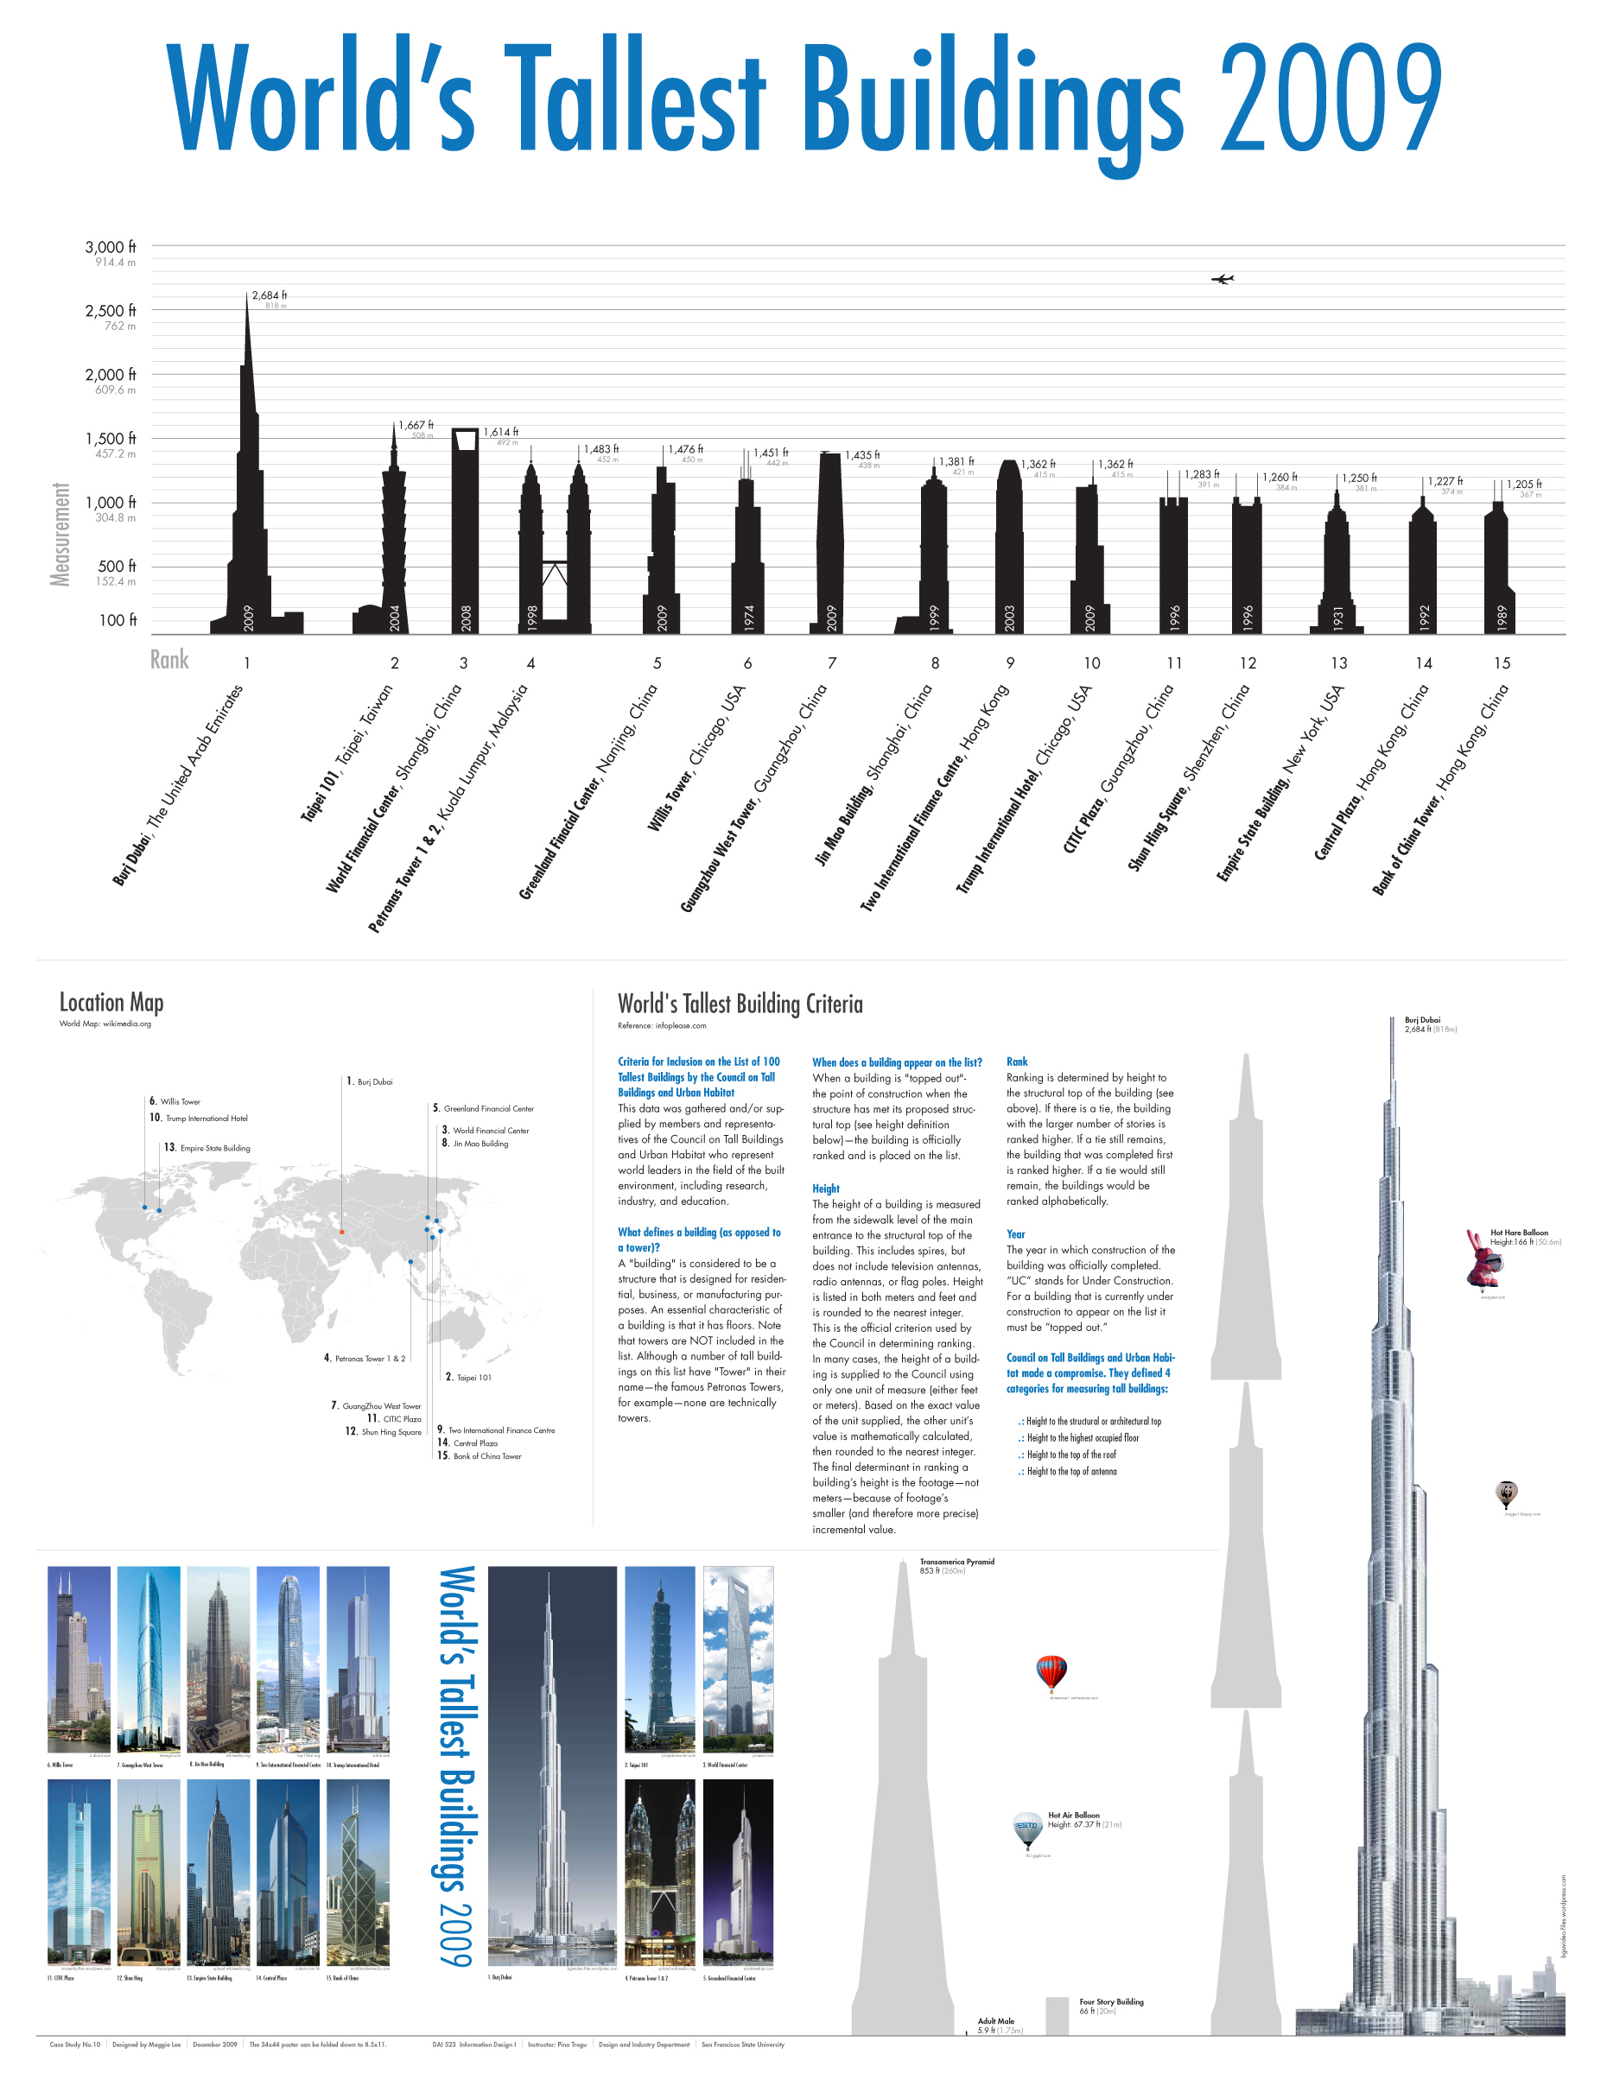
Figure 19. Student poster (#2) on the world’s tallest buildings in 2009. Poster size: 34 x 44 inches. Source: Author, (student work: M.L.) 2010.
Poster #1, like poster #2, starts off with a big title of the top, but the title in poster #1 requires more background knowledge than the title in poster #2. “Money Ball” refers to the book and the movie by the same title, about the Oakland Athletics, a team that advances to the playoffs and almost to the World Series despite its very minimal payroll budget. But the viewers who are not familiar with the book or the movie will not make that connection. The title in poster #2 means exactly what it says.
Whether the ambiguity of title #1 or the literal approach of title #2 is the better approach might depend entirely on the audience. If the audience for poster #1 is not familiar with the baseball world, then the title is already a stumbling block.
After the title, both posters present large graphics, one depicting relative salary and performance of baseball teams, from 2006 to 2008, the other showing the 15 tallest building in the world as of 2009. Poster #1 also includes playoff brackets from 2006 to 2008. More information such as pictures and text is included in the lower portion of both posters. As usual, in these examples the viewer needs to quickly assess the genre if his attention is to be retained long enough to proceed to the smaller, localized elements: images, text, maps, graphs, photos, and so on.
In examining the task, the viewer of poster #1 will be off to a very slow start, for the majority of the poster’s layout consists of two separate and very “visually active” graphs, where only one provides direct relevant information about the topic. The bar chart, while exactly visualizing the data, disproportionately takes over the space while providing only limited information. The graphic brackets showing the playoff pairings and results also offer limited information regarding the main theme of payroll and performance. The bar chart on the left does include relevant data, but its visual display is too busy due to the vibrations of the colors used.
From this quick assessment, it seems clear that poster #1 struggles to get off the ground and requires repeated “restarts” of attention and focus on the part of the reader, making the interaction a laborious and unsatisfying process.
Poster #2 on the other hand, provides a series of well-defined areas within the layout. First comes the clear, descriptive title, next is the large graphic—a pictorial bar chart made with the skyscrapers—which gives detailed information about height, rank, etc., followed by the world map with the geographic location of the buildings. Next, the explanatory text on the criteria for measuring the buildings offers a short but detailed introduction to the material, then the diagram of the tallest building compared to another smaller well-known building provides a clear understanding of the huge scale involved, and finally the photographs of the buildings themselves provide the most direct visual presentation of the material.
In short, every element, but especially the title and the large graphic, all contribute to capturing the viewer’s attention, and retaining it within those precious initial four seconds allowed by working memory. All the elements fulfill the expectations of the reader by adhering to visual schemes experienced earlier. The large graphic reads like a giant bar chart, the world map reads as a map, and the text is well arranged, with clear subtitles and concise paragraphs. The diagram with the stacked skyscrapers follows a familiar comparison device, and the familiar display of photos and captions complete this very informative piece.
Poster #2 then seems to satisfy the constraints of working memory by giving a quick snapshot of the topic, then by guiding the viewer through the smaller visual units.

Summary
This paper has focused on universal psychological principles that affect all graphics regardless of visual styles or modes of design. The specific visual examples that were chosen to explicate these principles represent a very narrow selection amongst the infinite variety of genres and media that could be analyzed. But this narrow choice confirms the specificity of the methods employed in design and their ad-hoc nature, in contrast with the common underlying psychological principles that can be generalized to include a majority of visual examples.
Because of this ad-hoc nature, each graphic must be contingent upon the cultural environment in which it is created and presented. Each graphic must employ visual conventions that are accepted in that culture at any specific time. Each graphic must assume a certain amount of background knowledge on the part of the viewer, or conversely, it must work to compensate for a perceived lack of background knowledge. Erring on the side of the latter is generally a good, common sense design approach and also shows editorial respect for the reader.
The enormous variation of styles, modes of design, cultural contingencies, and viewer’s background knowledge confirm that every graphic is an ad-hoc construction, each with its own specific visual style and mode of expression within the specific culture. In contrast to the extreme variability of visual formal aspects and the specificity of design methodologies, the main purpose of this paper has been to re-focus the attention of the designer on the more universal psychological principles that are at play, in a very general way, in all graphics, across multiple visual styles and multiple cultural visual conventions.
Further study is necessary in order to quantify the impact that a shift from focusing on the specific methods to focusing on general principles can have on the success of a graphic. In order to measure this success we can briefly borrow the definition of graphic “efficiency” from the late French cartographer Jacques Bertin:
EFFICIENCY is defined by the following proposition: If, in order to obtain a correct and complete answer to a given question, all other things being equal, one construction requires a shorter observation time than another construction, we can say that it is more efficient for this question. (Bertin 1983, p. 139)

An experiment aimed at measuring this efficiency can be set up where the responses of the subjects—the “observation times”—are recorded for the purpose of determining the most “efficient” graphics. These will be those graphics that require “less observation time” for comprehension and therefore are more likely to survive the very stringent limitation of the working memory bottleneck.
The experiment, when well constructed in its method, should include all the variability of visual styles, modes of design, cultural conventions, background knowledge, etc. With these variables taken into account—the “all other things being equal” in Bertin’s quote—the success of the graphic, its efficiency, can be measured by recording the length of the observation times required for quick closure.
Those graphics, or portions of those graphics whose required observation times match or fall within the time constraint of working memory, will prove to be successful, efficient graphics. In these graphics, meaningful information will survive the test of working memory and will be transferred to the more permanent storage of long-term memory.

References
Adams, William Lee, Sonia van Gilder Cooke, Megan Gibson, Kharunya Paramaguru, Judith Welikala, and Heather Jones (Graphics). “Trivia games.” Time, 30 July 2012: 94-95.
Bartlett, Frederic C. Remembering: a study in experimental and social psychology. Cambridge: Cambridge University Press, 1932.
Bertin, Jacques. Semiology of graphics. Madison, WI: The University of Wisconsin Press, 1983.
Bumiller, Elizabeth. Enemy lurks in briefings on Afghan war - PowerPoint - NYTimes.com. 26 April 2010. http://www.nytimes.com/2010/04/27/world/27powerpoint.html (accessed September 22, 2012).
Challand, Skylar. Designing a better subway map. 2 September 2010. http://idsgn.org/posts/designing-a-better-subway-map/ (accessed September 22, 2012).
Cooke, Sonia van Gilder, Megan Gibson, Kharunya Paramaguru, Judith Welikala, and Heather Jones (Graphics). “London lines.” Time, 30 July 2012: 26-27.
Cox, Amanda. Eyeo2012 - Amanda Cox. 10 July 2012. https://vimeo.com/45537437 (accessed September 15, 2012).
Engel, Richard. So what is the actual surge strategy? - World Blog. 2 December 2009. http://worldblog.nbcnews.com/_news/2009/12/02/4376696-so-what-is-the-actual-surge-strategy (accessed September 22, 2012).
Fairfield, Hanna. Driving safety, in fits and starts. 17 September 2012. http://www.nytimes.com/interactive/2012/09/17/science/driving-safety-in-fits-and-starts.html (accessed October 4, 2012).
Gombrich, Ernst H. The image and the eye: further studies in the psychology of pictorial representation. Oxford: Phaidon, 1982.
Hirsch, Jr., E. D. The philosophy of composition. Chicago, IL: The University of Chicago Press, 1977.
—. Validity in interpretation. New Haven: Yale University Press, 1967.
Miller, George A. “The magical number seven, plus or minus two: some limits on our capacity for processing information.” Psychological Review (American Psychological Association) 63, no. 2 (1956): 81-97.
Nagourney, Adam, Jeff Zeleny, and Shan Carter. The electoral map: key states - Election guide 2008 - The New York Times. 4 November 2008. http://elections.nytimes.com/2008/president/whos-ahead/key-states/map.html (accessed October 2, 2012).
Novak, Joseph D., and D. Bob Gowin. Learning how to learn. Cambridge: Cambridge University Press, 1984.
Novak, Joseph D., and J. Alberto Cañas. The theory underlying concept maps and how to construct and use them. Technical, Technical Report IHMC CmapTools 2006-01 Rev 01-2008, Florida Institute for Human and Machine Cognition, Pensacola: IHMC, 2008.
PA Consulting Group. “Afghanistan_Dynamic_Planning.pdf.” msn.com. 2 December 2009. http://msnbcmedia.msn.com/i/MSNBC/Components/Photo/_new/Afghanistan_Dynamic_Planning.pdf (accessed September 22, 2012).
The New York Times. President map - Election results 2008 - The New York Times. 9 December 2008. http://elections.nytimes.com/2008/results/president/map.html (accessed October 2, 2012).

Pino Trogu: Department of Design and Industry/College of Liberal and Creative Arts | San Francisco State University | USA | e-mail: trogu@sfsu.edu

