PINO TROGU – SAN FRANCISCO STATE UNIVERSITY

BIOCLAMPING:
ARISTOTLE’S LANTERN

GIORGIO SCARPA’S MODEL OF THE MASTICATORY APPARATUS OF THE SEA URCHIN… AND MORE.

ME411095: BIO-INSPIRED DESIGN
DELFT UNIVERSITY OF TECHNOLOGY


go to last slide

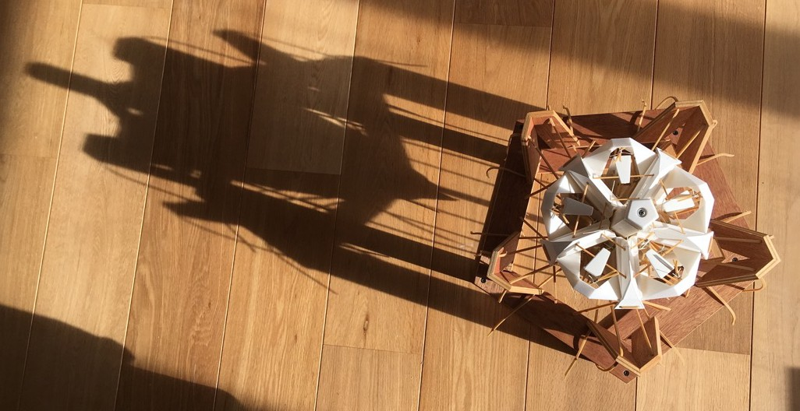

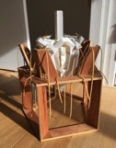
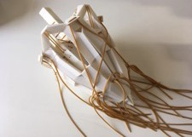
Lantern replicant 2. Delft, NL, 19 Oct. 2017

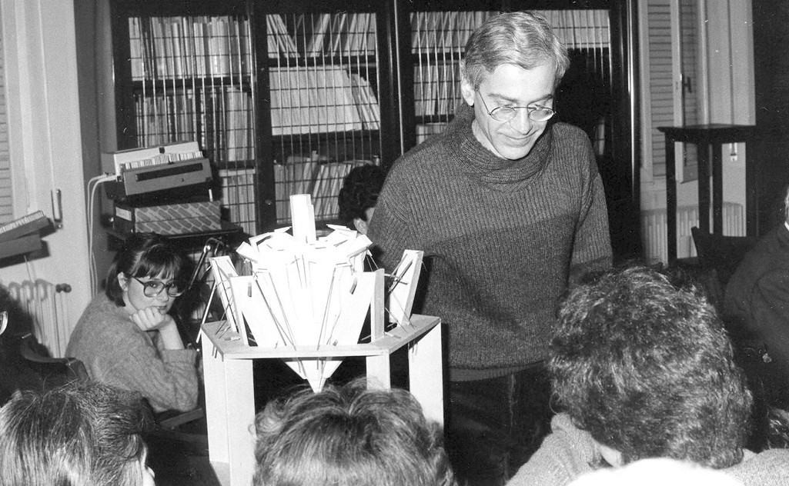

Giorgio Scarpa’s bio-inspired and geometric folding models.

THE SEA URCHIN

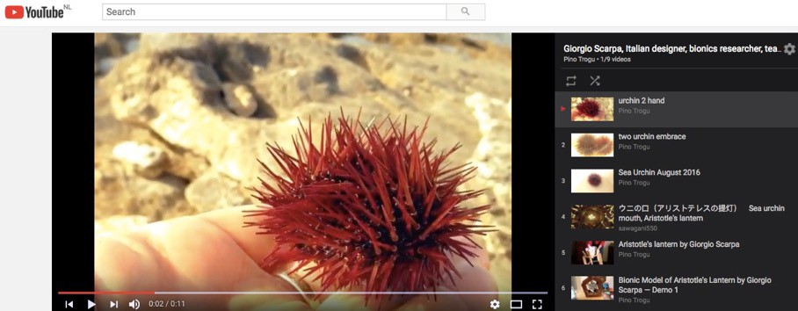

Scarpa YouTube Playlist: https://www.youtube.com/playlist?list=PLM4DV2CfgpjuCtWNJP3iQKRRlFbdMUvim

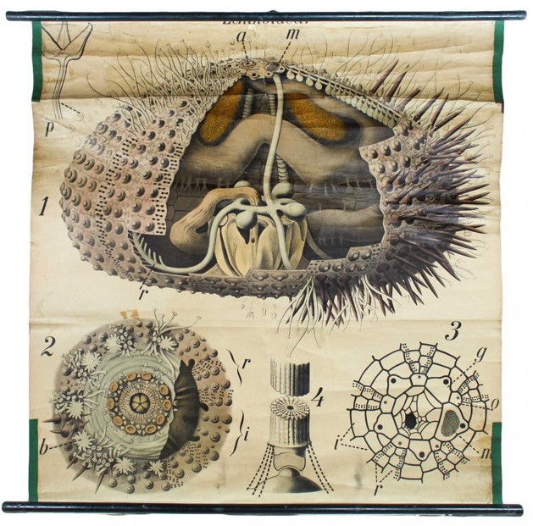

Chart Sea Urchin by Paul Pfurtscheller, 1907: https://www.pamono.com/antique-wall-chart-sea-urchin-by-paul-pfurtscheller-1907-1

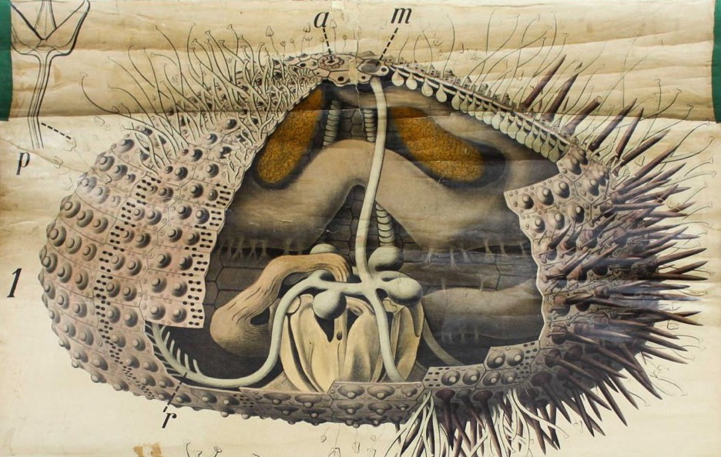

Chart Sea Urchin by Paul Pfurtscheller, 1907: https://www.pamono.com/antique-wall-chart-sea-urchin-by-paul-pfurtscheller-1907-1

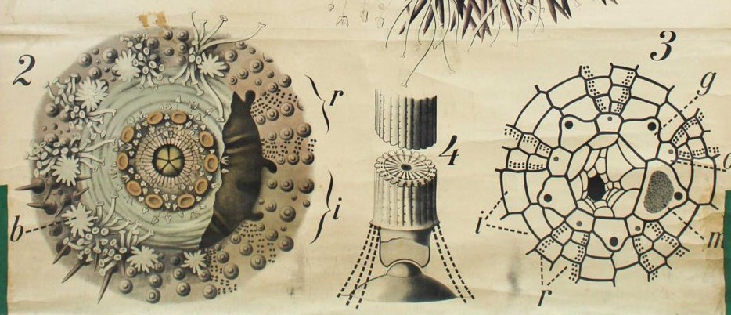

Chart Sea Urchin by Paul Pfurtscheller, 1907: https://www.pamono.com/antique-wall-chart-sea-urchin-by-paul-pfurtscheller-1907-1

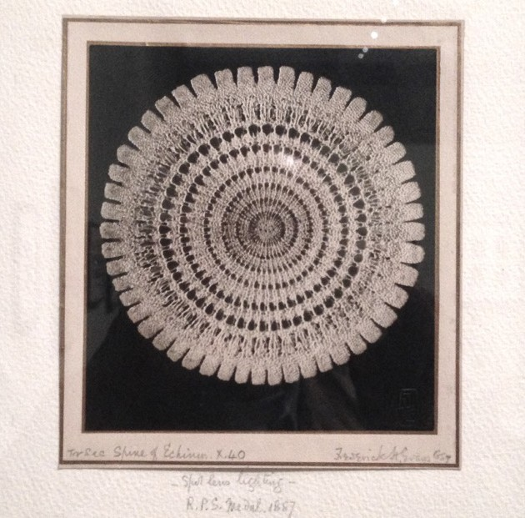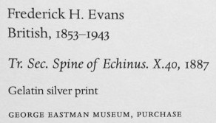

Morgan Library & Museum, New York

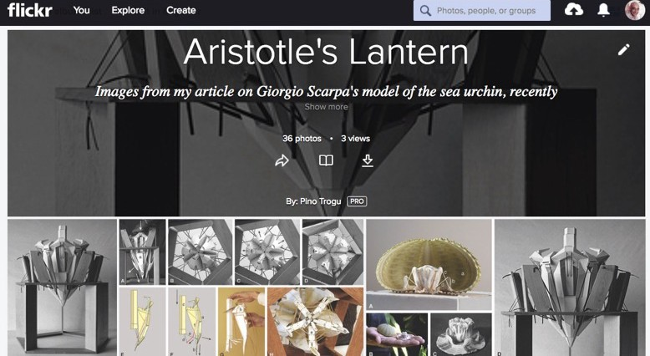

Scarpa Flickr Album: https://www.flickr.com/photos/pinotrogu/albums/72157661343652018

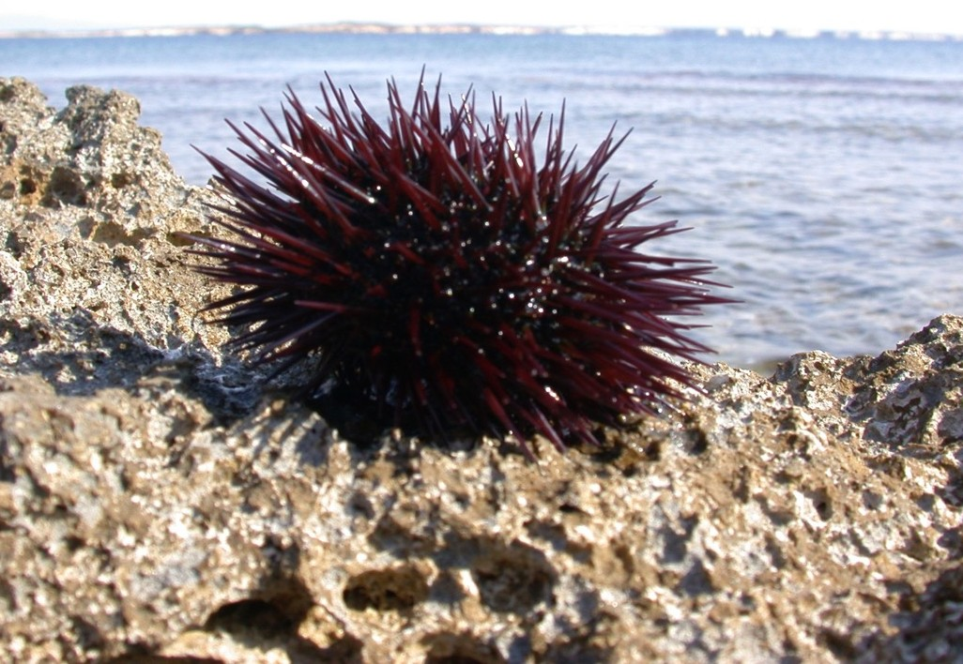

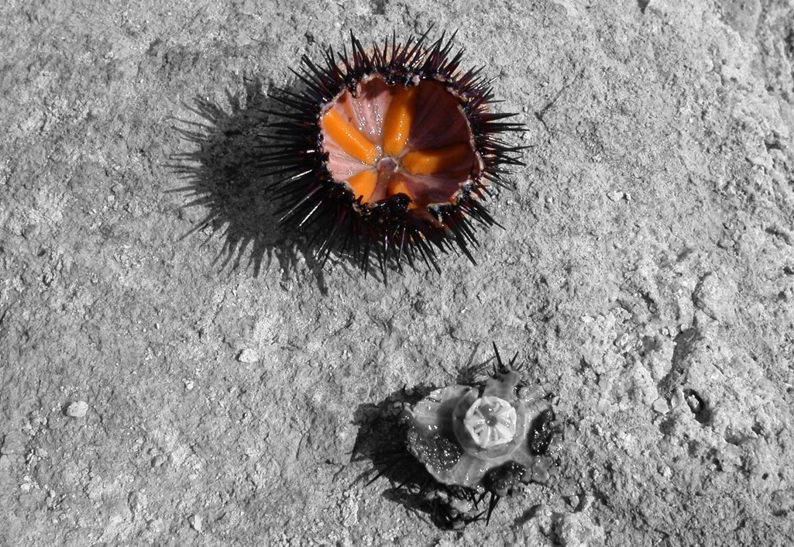

PINO TROGU BIOCLAMPING: ARISTOTLE’S LANTERN ME411095 BIO-INSPIRED DESIGN 20 OCTOBER 2017 12

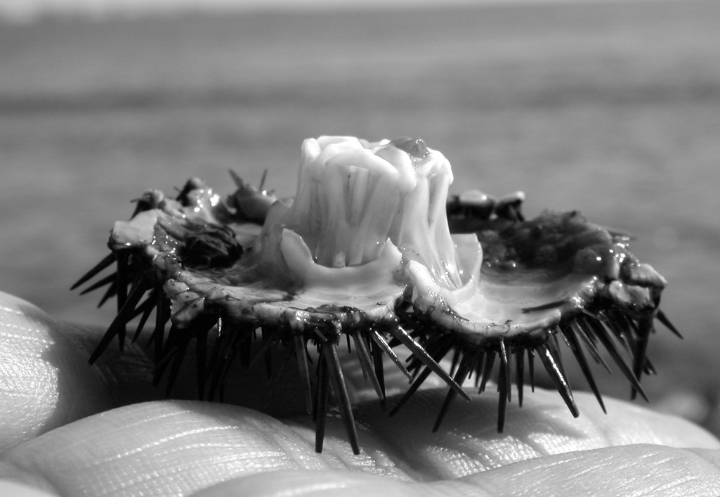

PINO TROGU BIOCLAMPING: ARISTOTLE’S LANTERN ME411095 BIO-INSPIRED DESIGN 20 OCTOBER 2017 13

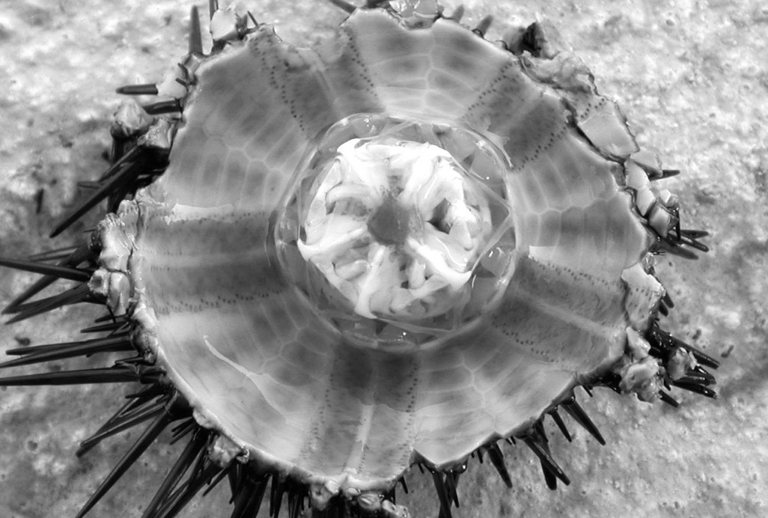

PINO TROGU BIOCLAMPING: ARISTOTLE’S LANTERN ME411095 BIO-INSPIRED DESIGN 20 OCTOBER 2017 14

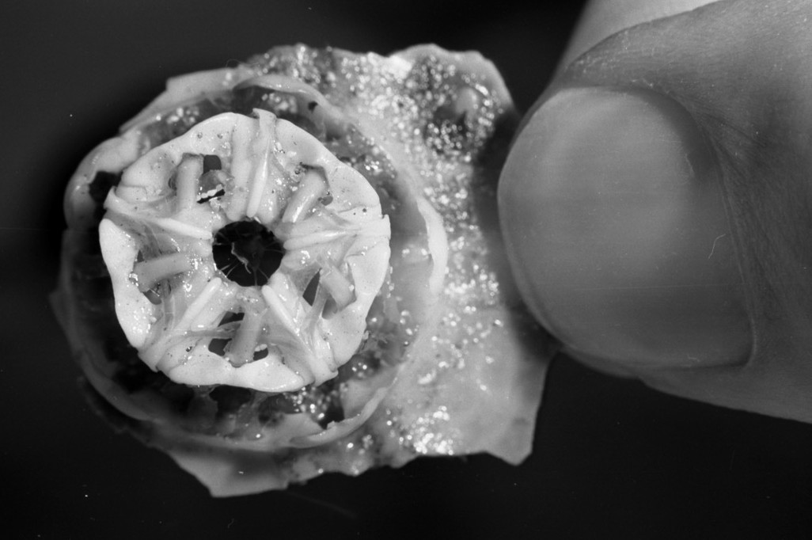

Photo: Giorgio Cireddu

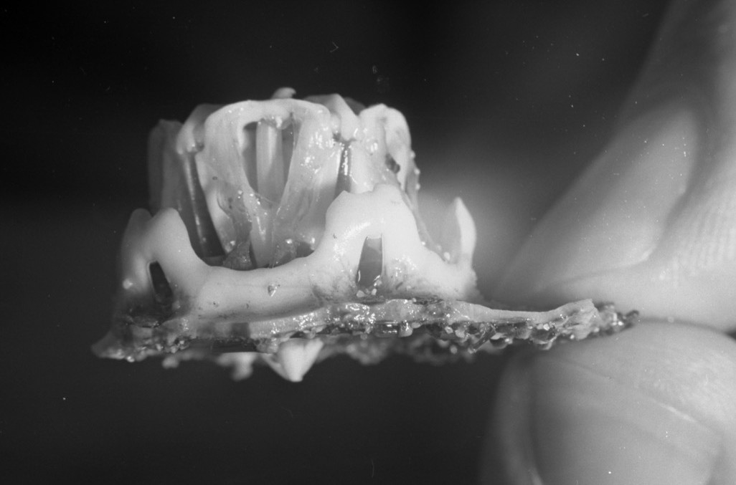

Photo: Giorgio Cireddu

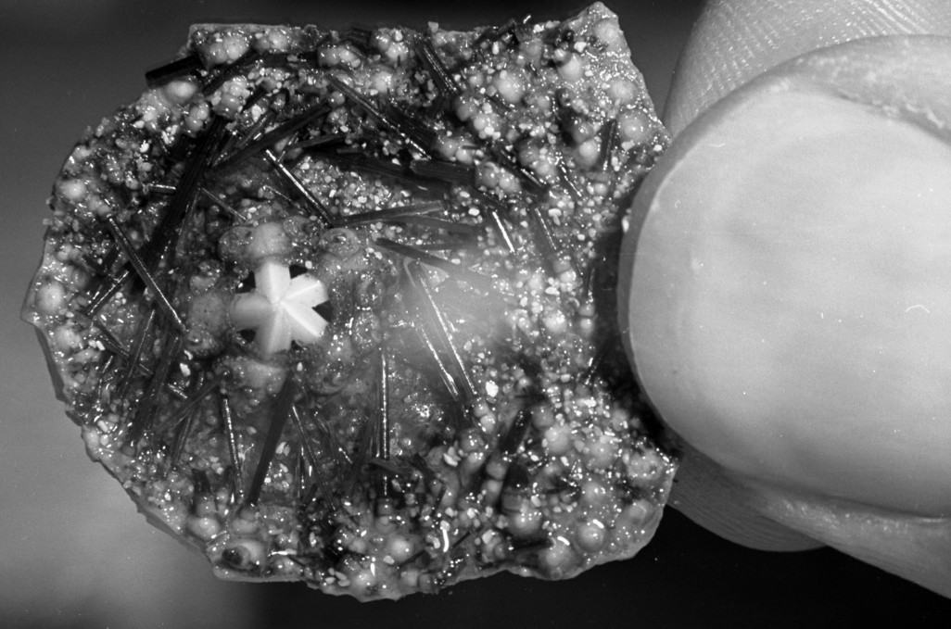

Photo: Giorgio Cireddu

BIONIC MODEL OF
ARISTOTLE’S LANTERN

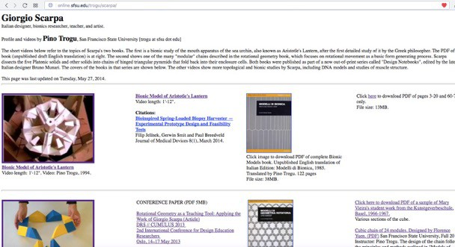http://online.sfsu.edu/trogu/scarpa/

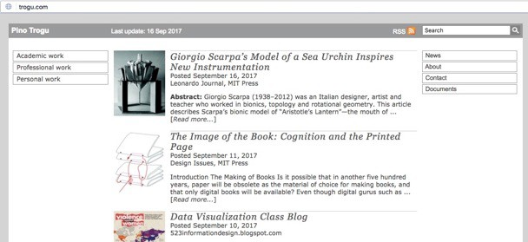trogu.com

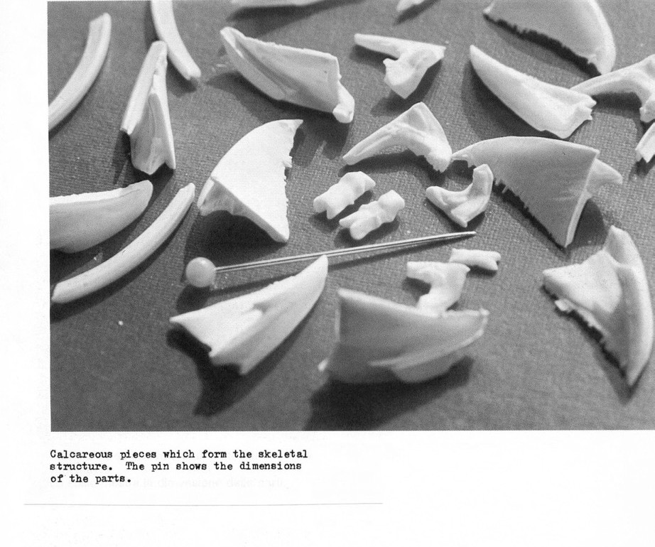

Scarpa, Giorgio, Modelli di bionica: capire la natura attraverso i modelli. Quaderni di design 13, ed. B. Munari (Bologna: Zanichelli, 1985).

PINO TROGU BIOCLAMPING: ARISTOTLE’S LANTERN ME411095 BIO-INSPIRED DESIGN 20 OCTOBER 2017 20

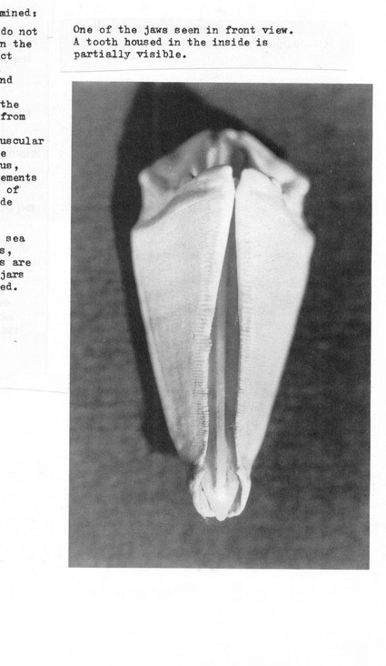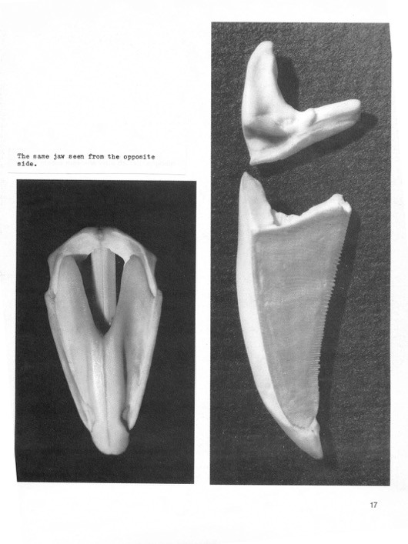
Scarpa, Giorgio, Modelli di bionica,1985.

PINO TROGU BIOCLAMPING: ARISTOTLE’S LANTERN ME411095 BIO-INSPIRED DESIGN 20 OCTOBER 2017 21

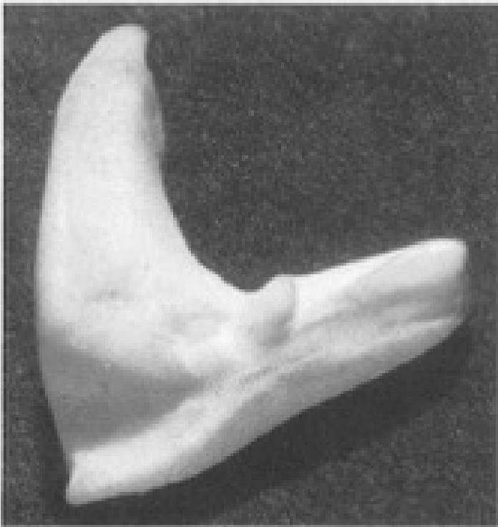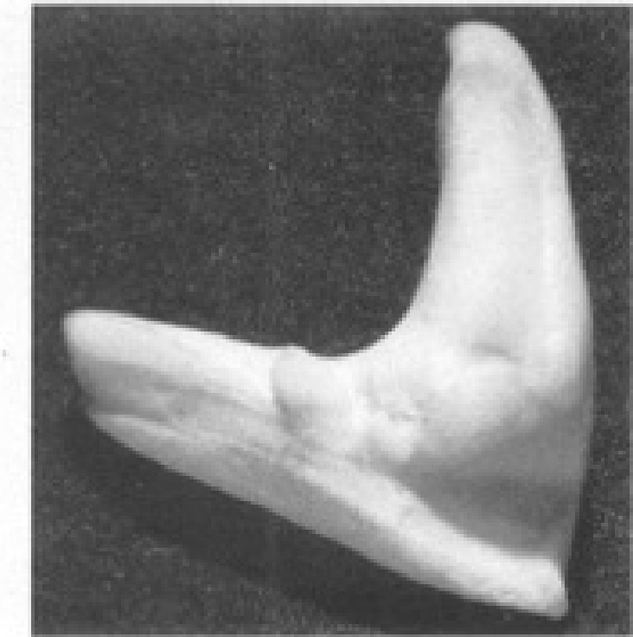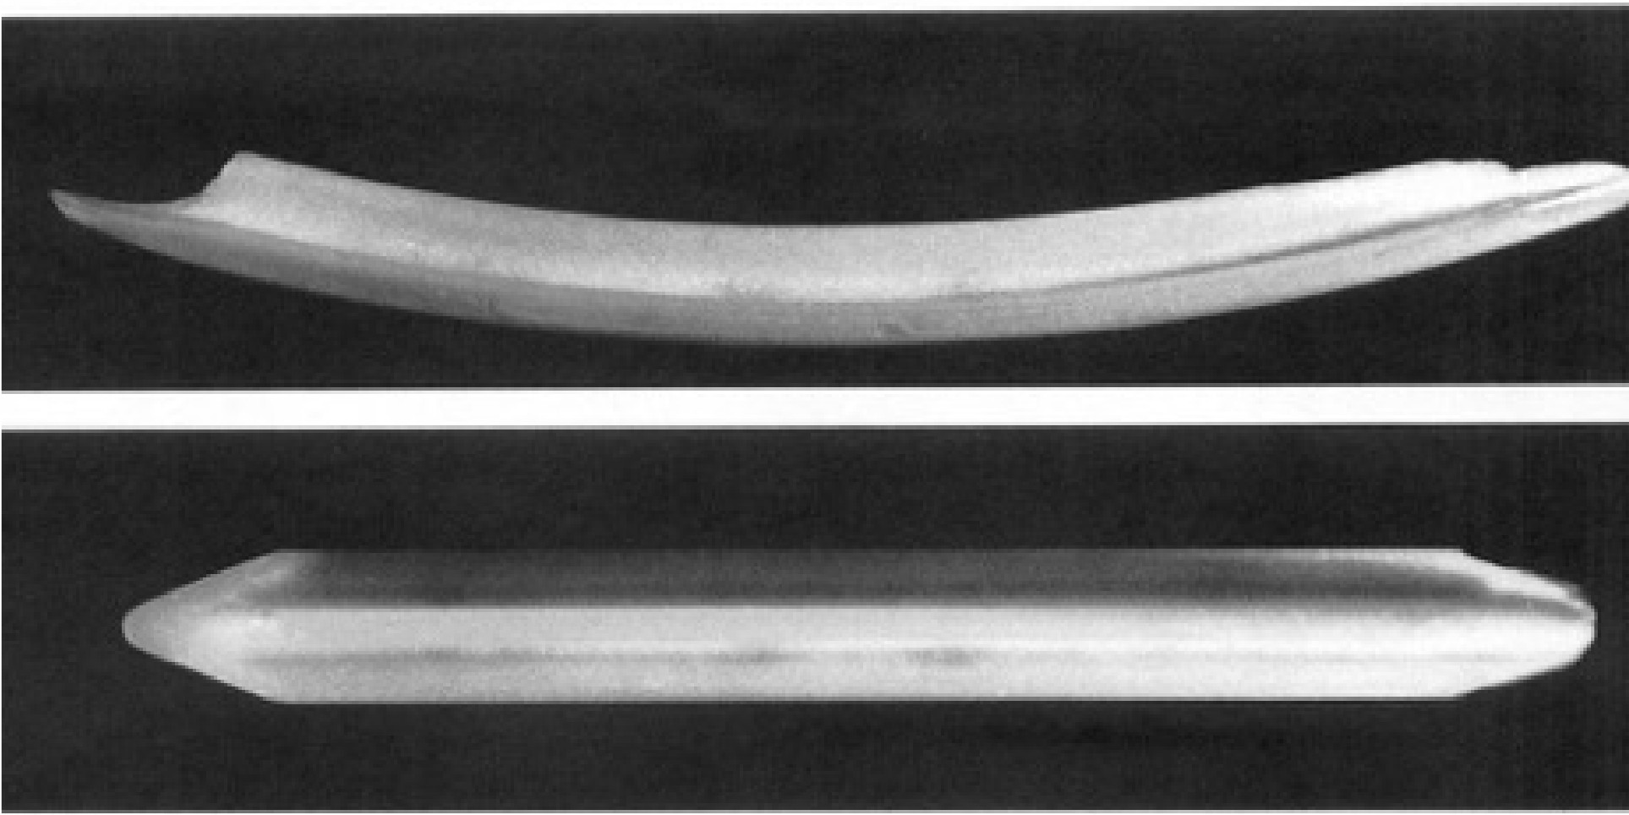

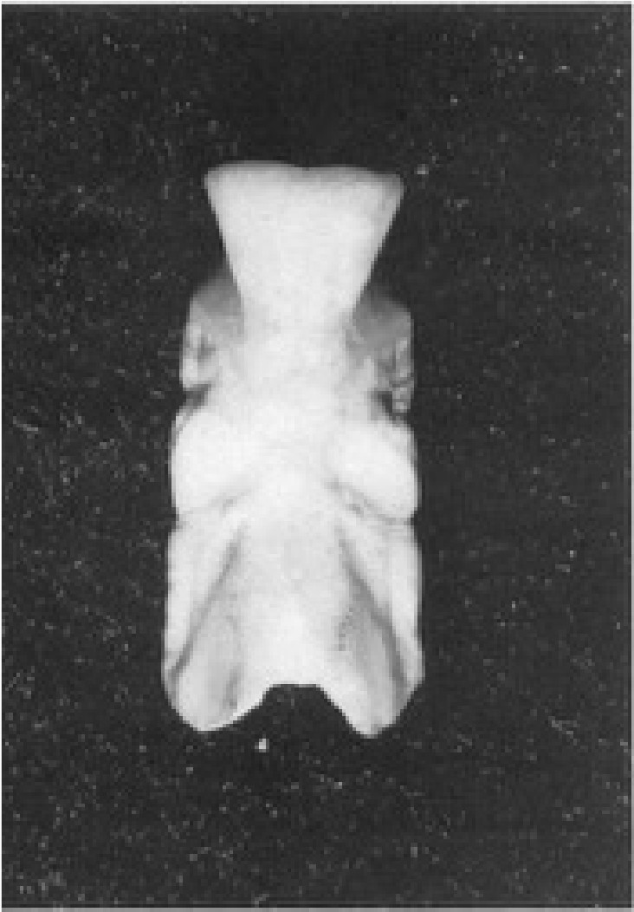
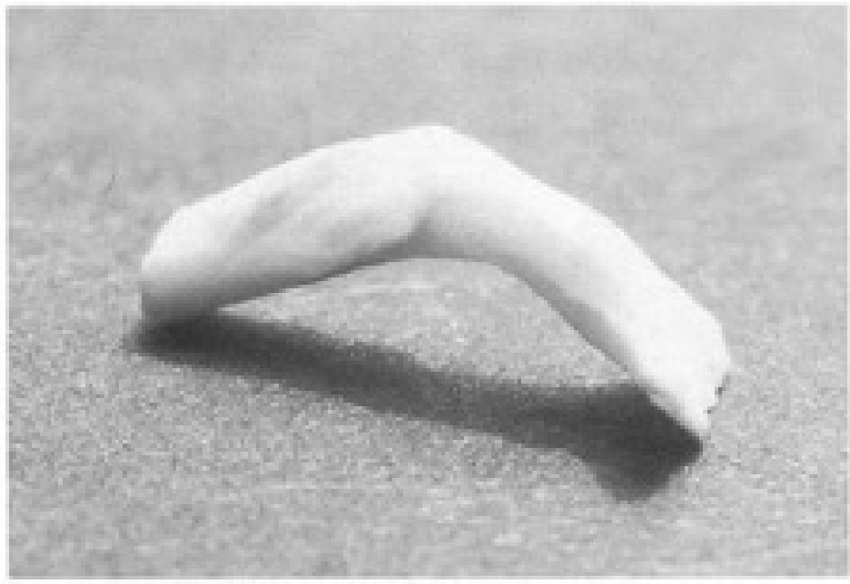

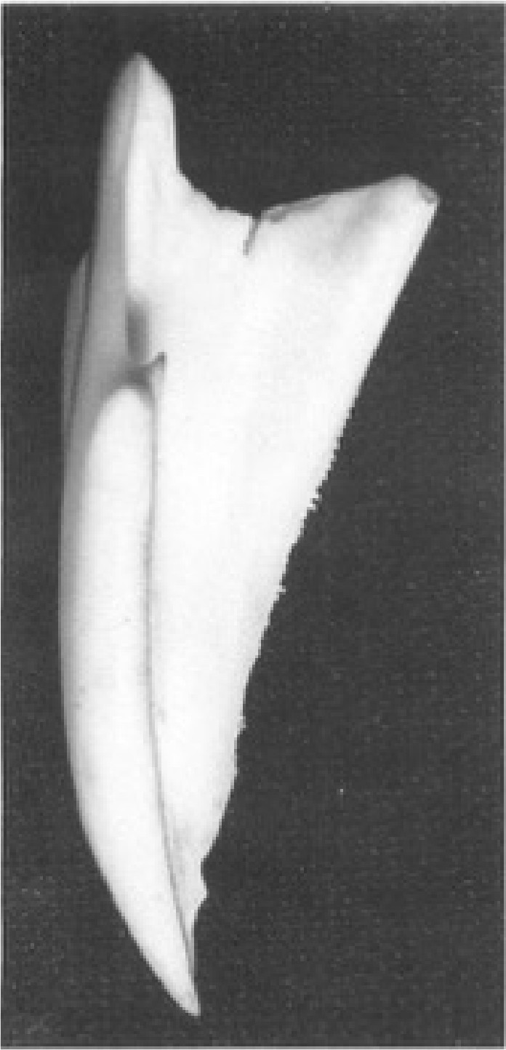
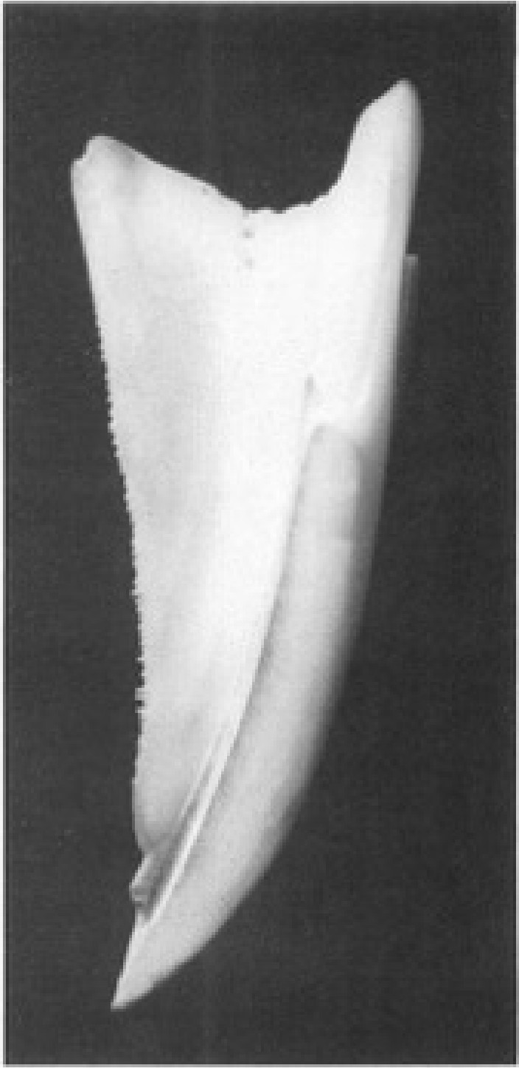
- n11ll 1o'bci;we N"t t i;l 1 lr.ie,

Q '!I' Cclm:I iil'br · Ilk Ul!fl'° 'IMll'it l'illlll .- l,
, o!" 'b d!ec o · . . ,o tOYr •

,a
P,:4;' rt o:r i • h.
Rr1

Scarpa, Giorgio, Modelli di bionica,1985.

TU Delft
PINO TROGU BIOCLAMPING: ARISTOTLE’S LANTERN ME411095 BIO-INSPIRED DESIGN 20 OCTOBER 2017 22

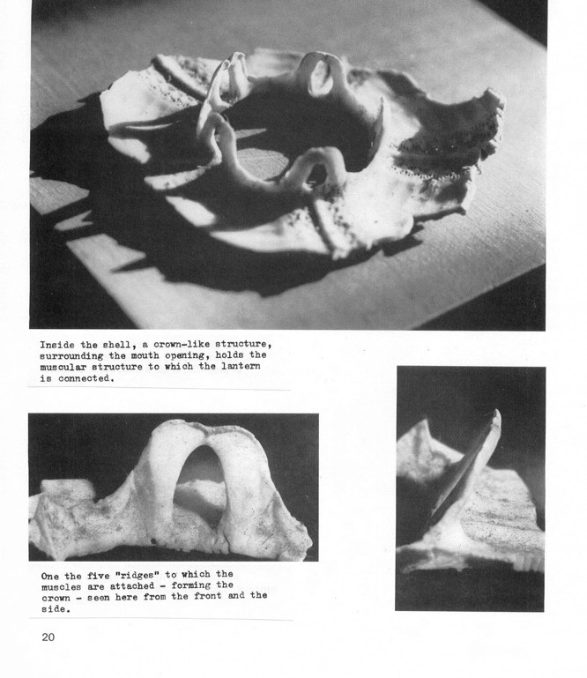

Scarpa, Giorgio, Modelli di bionica,1985.

PINO TROGU BIOCLAMPING: ARISTOTLE’S LANTERN ME411095 BIO-INSPIRED DESIGN 20 OCTOBER 2017 23

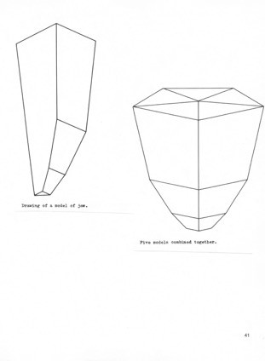

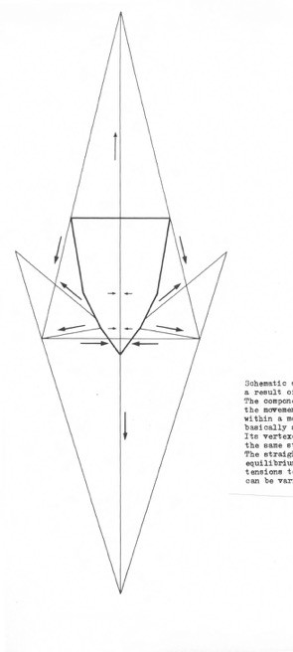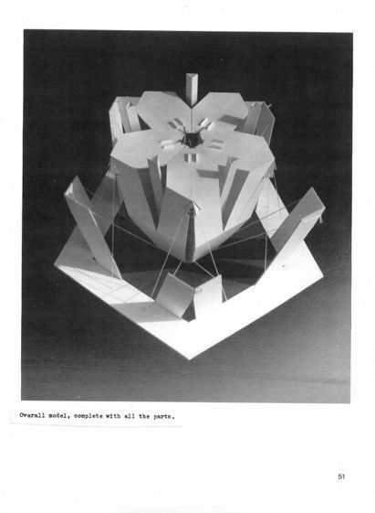Scarpa, Giorgio, Modelli di bionica,1985.

PINO TROGU BIOCLAMPING: ARISTOTLE’S LANTERN ME411095 BIO-INSPIRED DESIGN 20 OCTOBER 2017 24

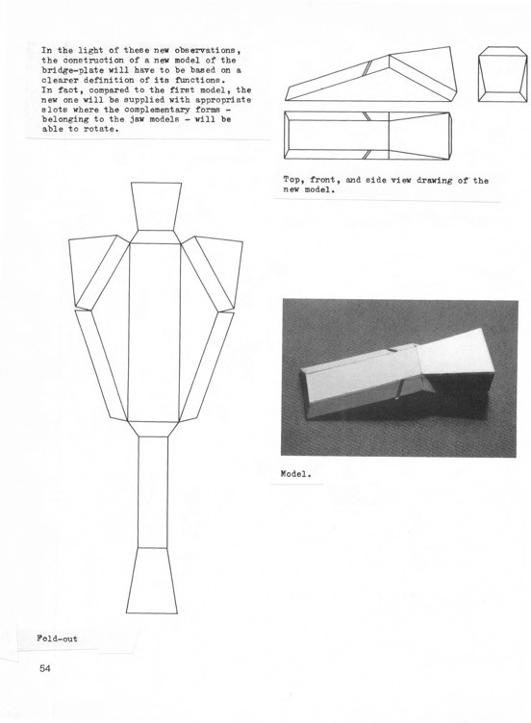

Scarpa, Giorgio, Modelli di bionica,1985.

PINO TROGU BIOCLAMPING: ARISTOTLE’S LANTERN ME411095 BIO-INSPIRED DESIGN 20 OCTOBER 2017 25

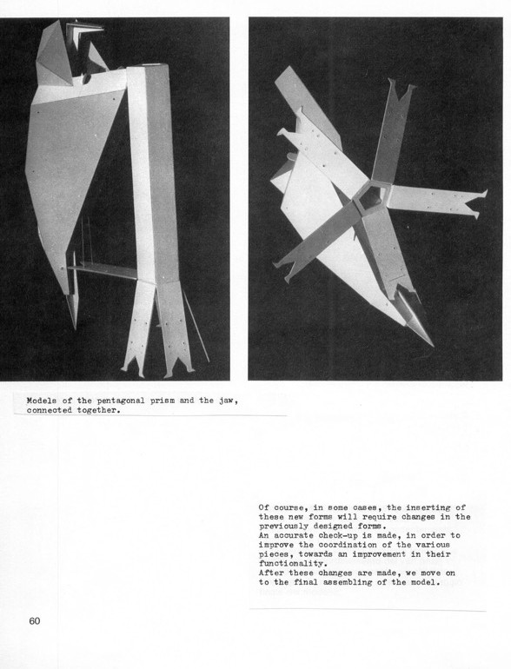

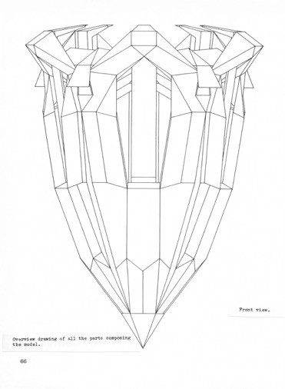

Scarpa, Giorgio, Modelli di bionica,1985.

PINO TROGU BIOCLAMPING: ARISTOTLE’S LANTERN ME411095 BIO-INSPIRED DESIGN 20 OCTOBER 2017 26

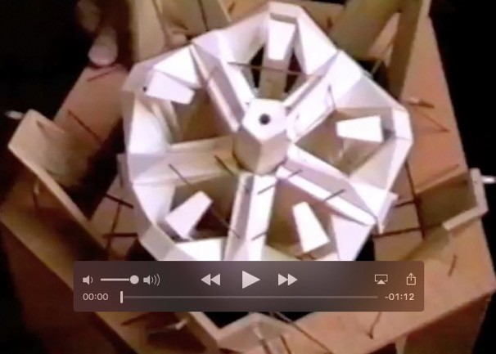

Bionic Model of Aristotle's Lantern by Giorgio Scarpa -- Youtube video

Scarpa, Giorgio, Modelli di bionica,1985.

GIORGIO SCARPA’S MODEL OF A SEA URCHIN
INSPIRES NEW INSTRUMENTATION

PDF: static.trogu.com/documents/scarpa/leon_a_01384.pdf
Trogu, 2016
Leonardo Just Accepted MS. doi: 10.1162/LEON_a_01384
© ISAST

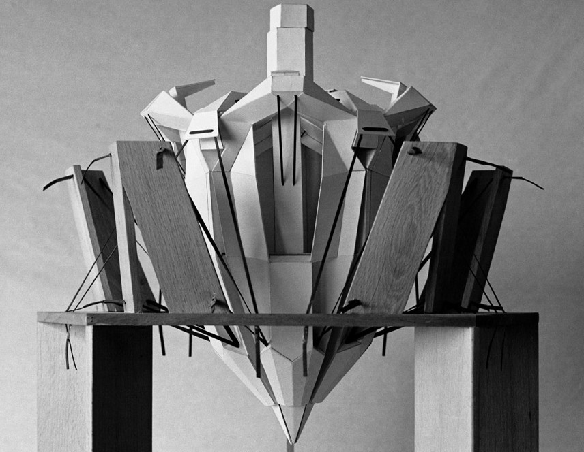

Photo: Giorgio Cireddu

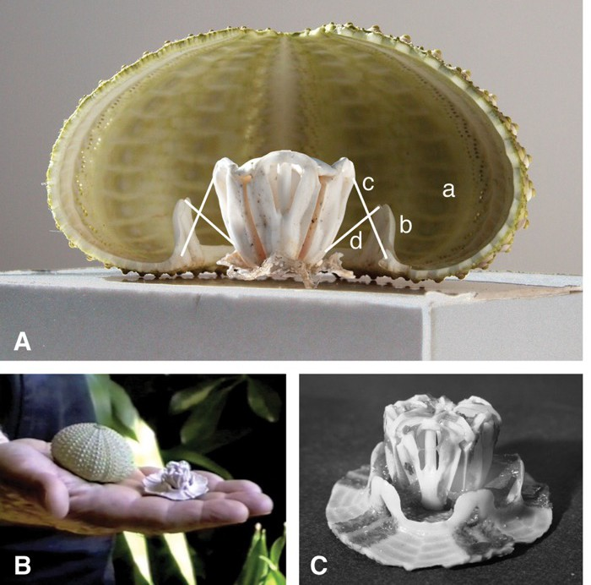
Photo: Giorgio Cireddu

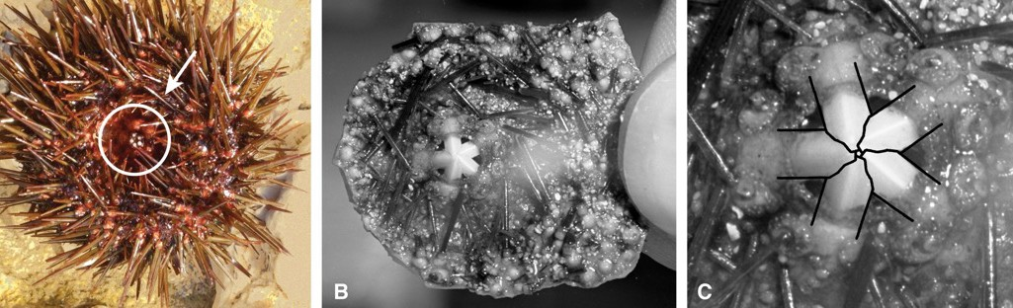
Photo: Giorgio Cireddu

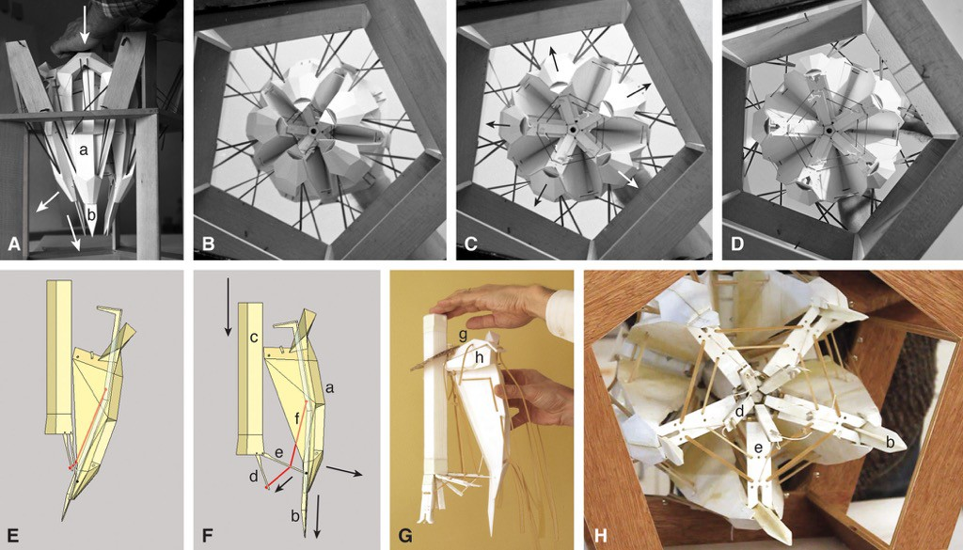
Photo: Giorgio Cireddu

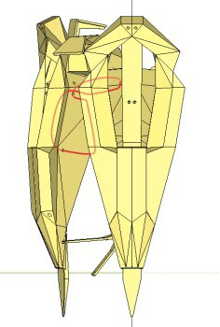
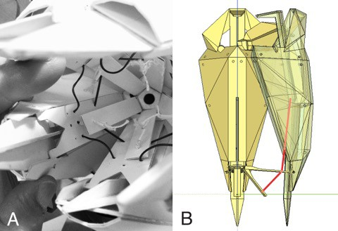
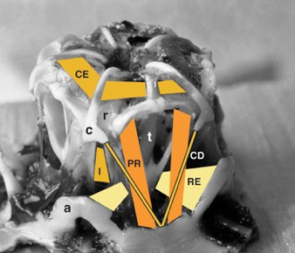
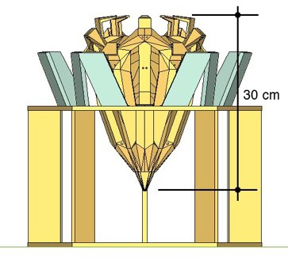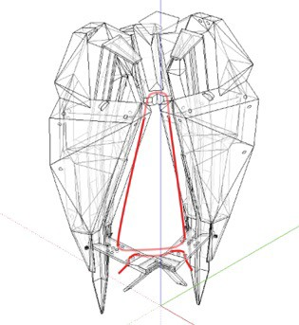

THE GROUND SAMPLER OF FRANK ET AL.

(Frank et al, UC San Diego, 2015)

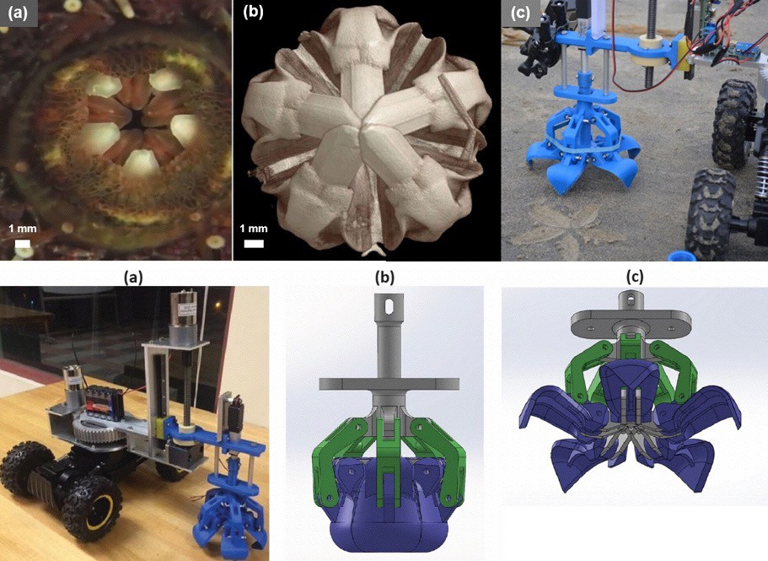
(Frank et al, UC San Diego, 2015)

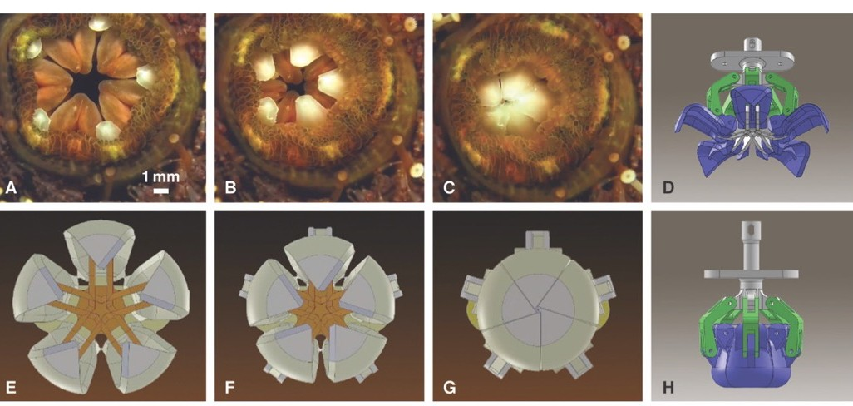
(Frank et al, UC San Diego, 2015)

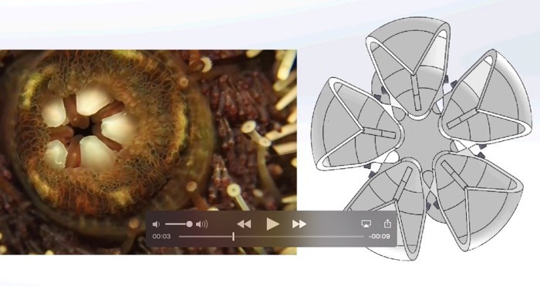

Frank et al., UCSD urchin side-by-side video

(Frank et al, UC San Diego, 2015)

THE BIOPSY HARVESTER OF JELÍNEK ET AL.

(Jelínek, Smit, Breedveld, TU Delft; ACMIT, Austria, 2014)

Filip Jelínek Giorgio Scarpa

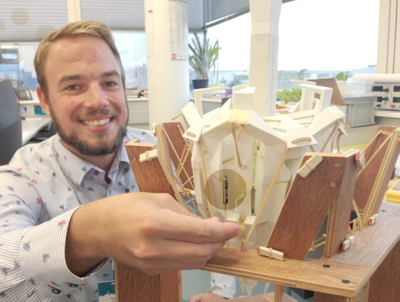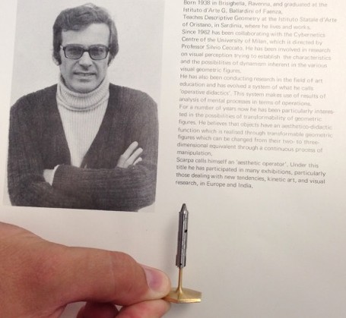(Jelínek, Smit, Breedveld, TU Delft; ACMIT, Austria, 2014)

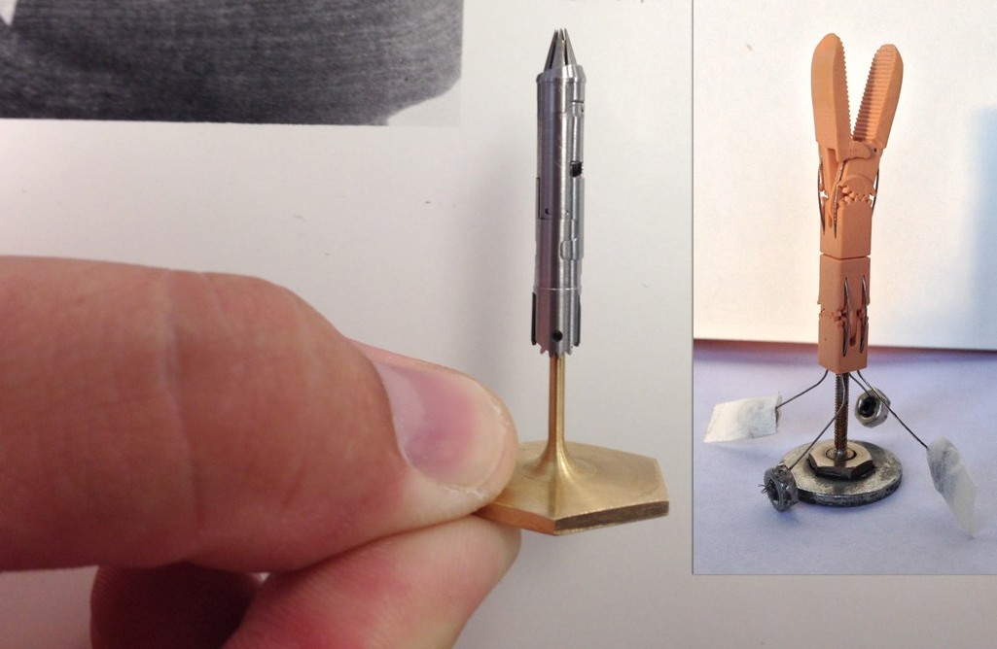

(Jelínek, Smit, Breedveld, TU Delft; ACMIT, Austria, 2014)

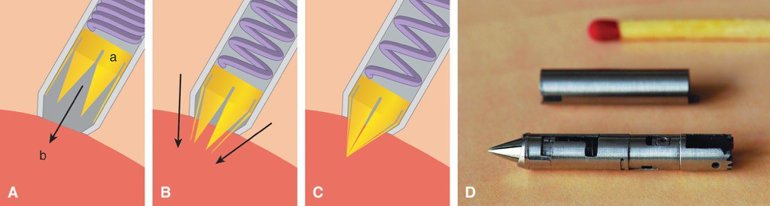
(Jelínek, Smit, Breedveld, TU Delft; ACMIT, Austria, 2014)

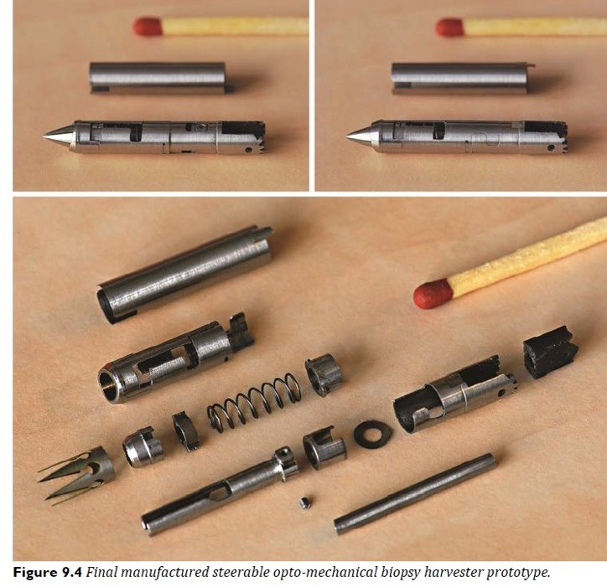

(Jelínek, Smit, Breedveld, TU Delft; ACMIT, Austria, 2014)

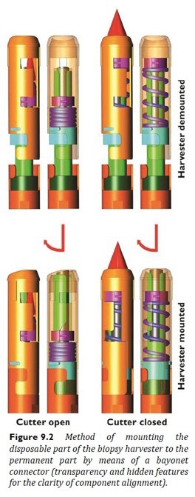

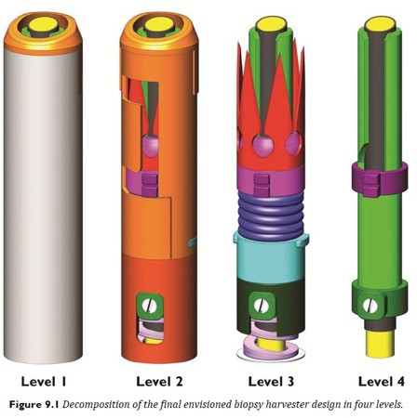

(Jelínek, Smit, Breedveld, TU Delft; ACMIT, Austria, 2014)

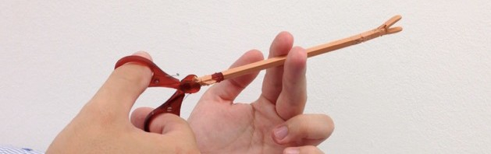

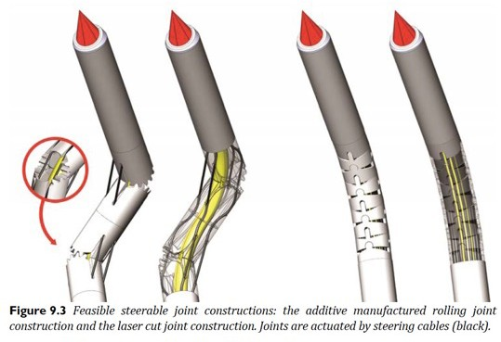
Jelínek, Filip, Steering and Harvesting Technology for Minimally Invasive Biopsy
Jelínek, Filip, Steering and Harvesting Technology for Minimally Invasive Biopsy

PhD dissertation
doi:10.4233/uuid:18bc7cc6-153b-4ffe-8da1-474f08a212fc Delft University of Technology, 2015

BIONICS: EXPLORATION
BETWEEN PLAY AND RESEARCH

To play (to explore) is something that costs nothing and brings the mind closer to its desires by asking about the goals and function of every choice, so that every project, before it even becomes an application in its diversified specificity, every project should mean freedom and spontaneity in making, a non-paralyzing immersion, a contrast to what surrounds us, in a seamless process. […]

The image of destroyed sea urchins, their scattered fragments in the sand, and of the live sea urchins observed in their marine habitat, are the source of this study. […]

Not a single sea urchin was sacrificed in order to study it.
Giorgio Scarpa, c. 1970

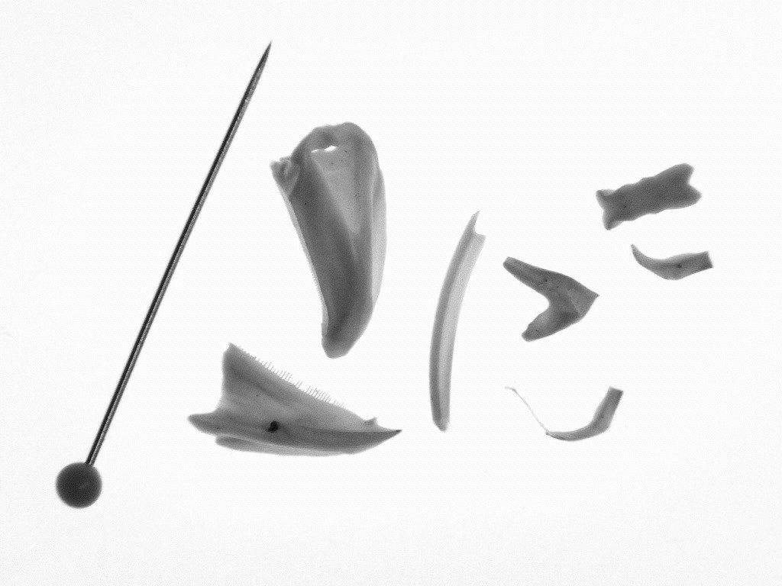

PINO TROGU BIOCLAMPING: ARISTOTLE’S LANTERN ME411095 BIO-INSPIRED DESIGN 20 OCTOBER 2017 47

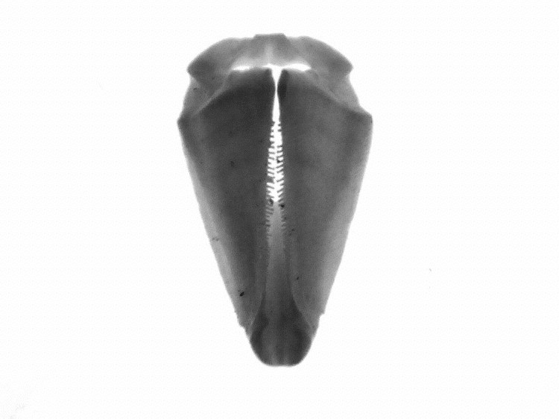

PINO TROGU BIOCLAMPING: ARISTOTLE’S LANTERN ME411095 BIO-INSPIRED DESIGN 20 OCTOBER 2017 48

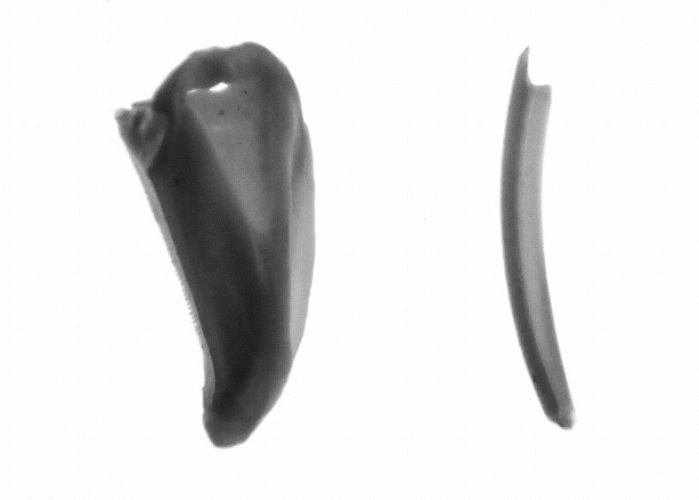

PINO TROGU BIOCLAMPING: ARISTOTLE’S LANTERN ME411095 BIO-INSPIRED DESIGN 20 OCTOBER 2017 49

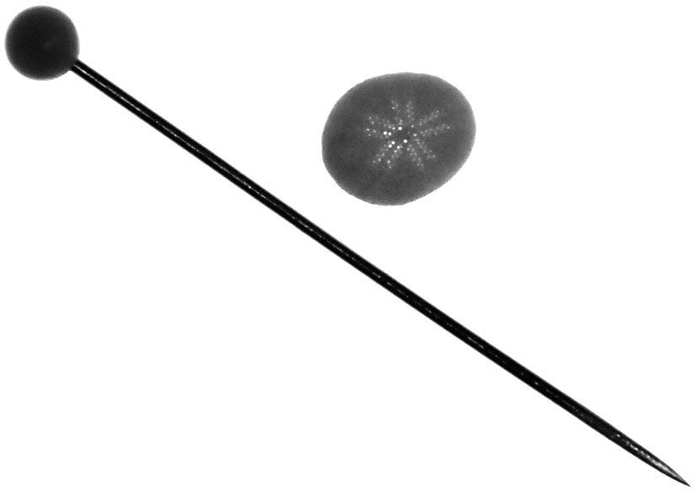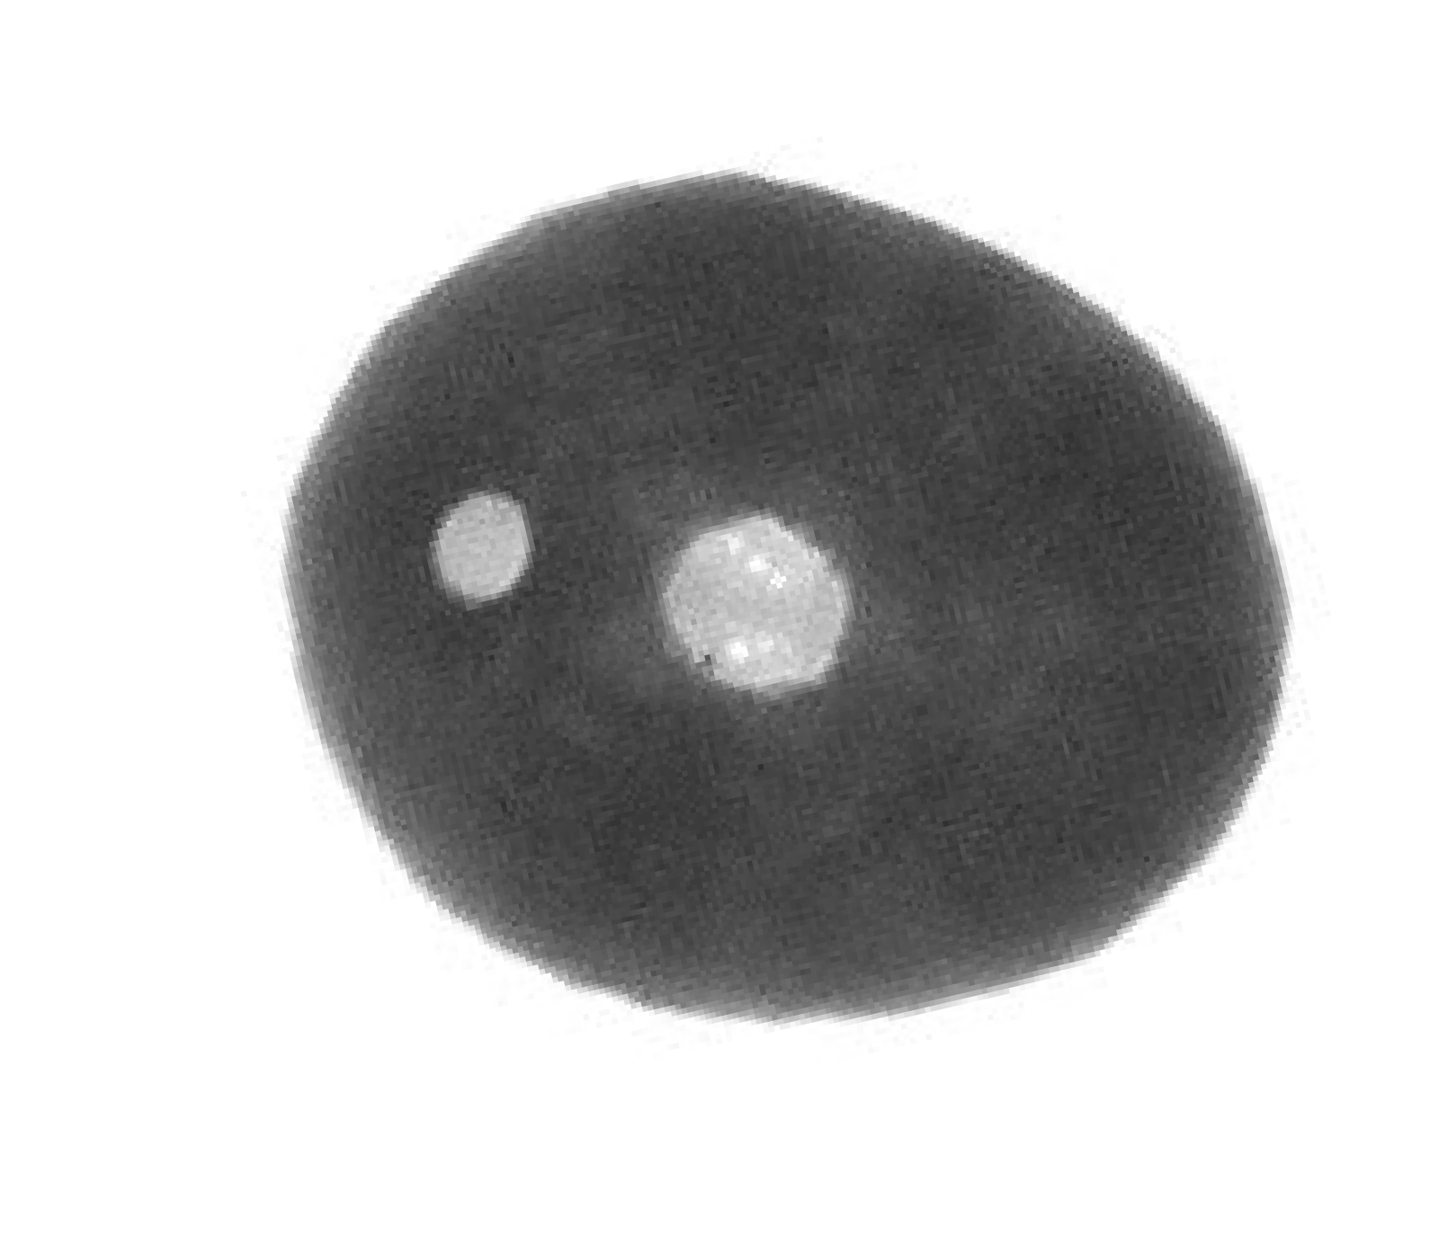

PINO TROGU BIOCLAMPING: ARISTOTLE’S LANTERN ME411095 BIO-INSPIRED DESIGN 20 OCTOBER 2017 50

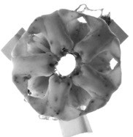

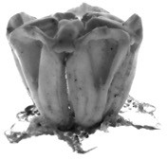

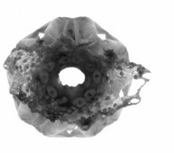

PINO TROGU BIOCLAMPING: ARISTOTLE’S LANTERN ME411095 BIO-INSPIRED DESIGN 20 OCTOBER 2017 51

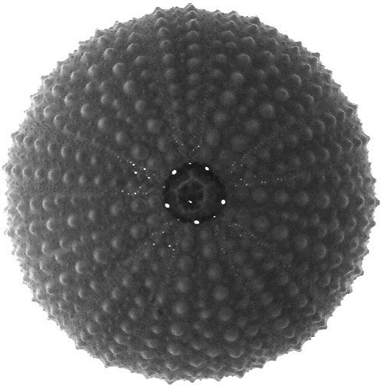

PINO TROGU BIOCLAMPING: ARISTOTLE’S LANTERN ME411095 BIO-INSPIRED DESIGN 20 OCTOBER 2017 52

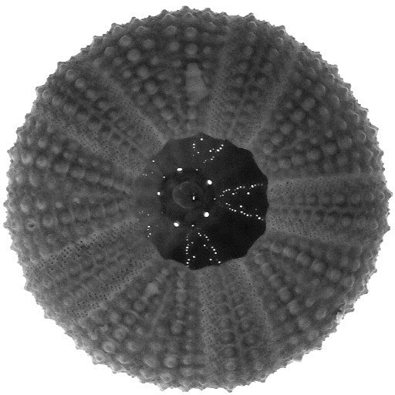

“If you are going to do research in bionics, don’t forget to study seeds, for the knowledge that nature displays in their creation, and for the originality and unpredictability of some of their self-dispersal mechanisms.”

Giorgio Scarpa, 1988

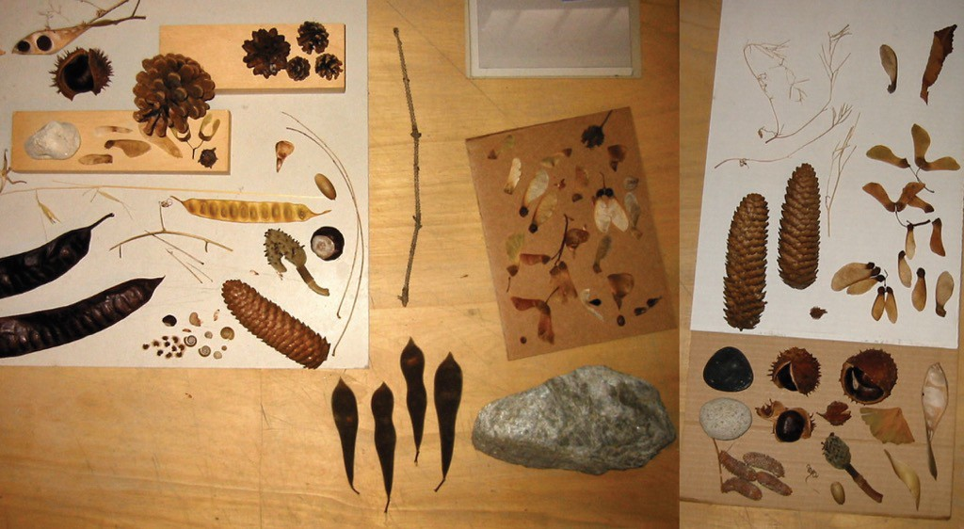

Giorgio Scarpa’s collection of seeds on his workshop’s desk in Castel Bolognese, Italy, 2002. (© Pino Trogu)

…AND MORE???

BIOINSPIRED
GEOMETRIC FOLDING MODELS (ORIGAMI)

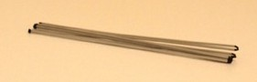

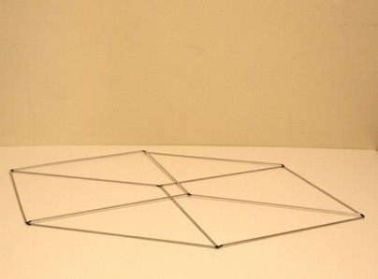
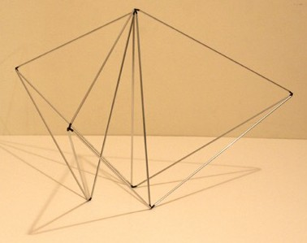

Scarpa, Transformable cube, 1965.

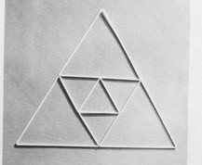

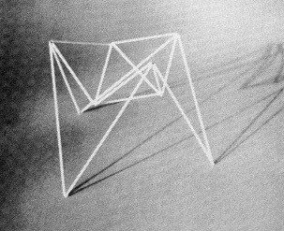
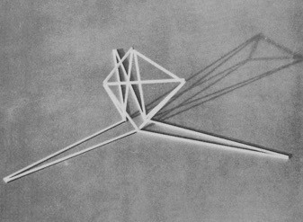
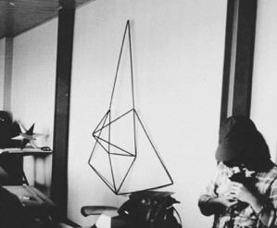

Scarpa, Transformable triangle, 1965.

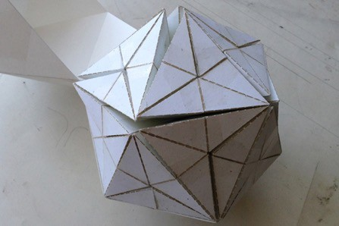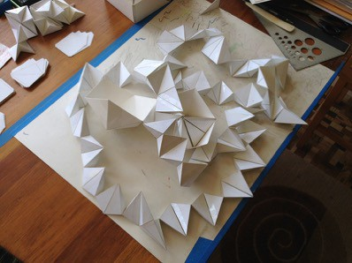

(Trogu & Nies, model based on Scarpa, 2015)

Scarpa, Models of Rotational Geometry, p. 112, & cover.

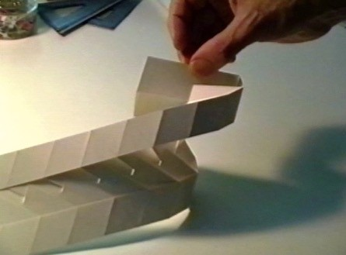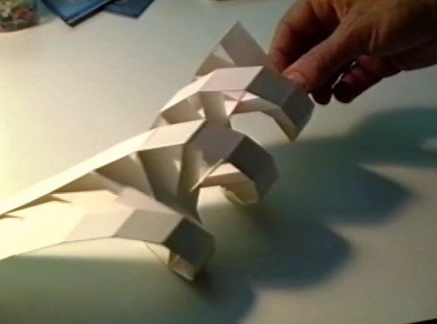

Scarpa, DNA model, circa 1980.

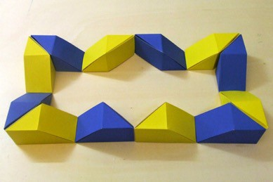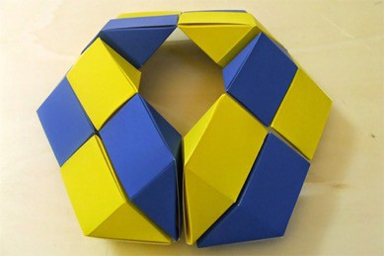
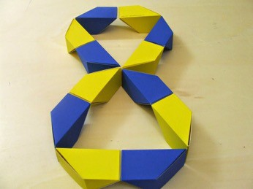
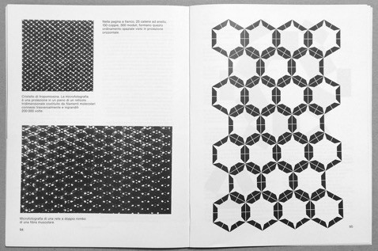

Scarpa, Models of Rotational Geometry, pp. 73, 95, & cover.

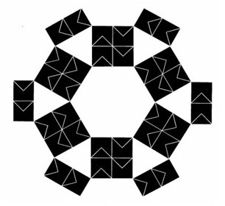
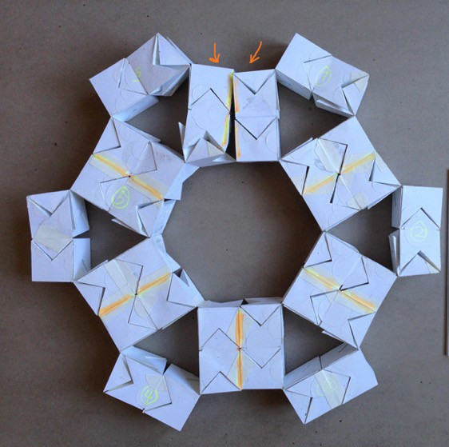
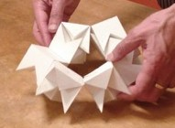
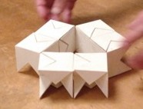
Scarpa, Models of Rotational Geometry, pp. 66-68, 96

(Trogu & Nies, prototype, 2015)

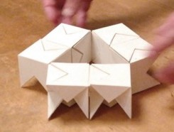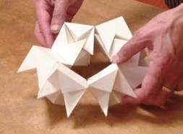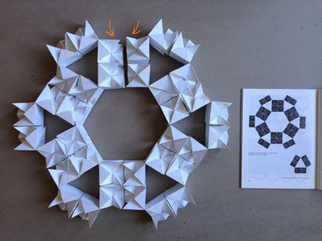
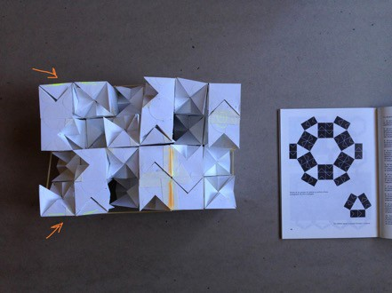
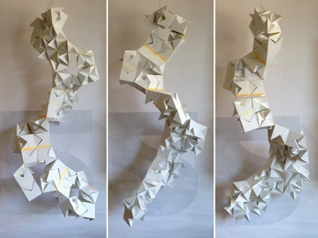
Scarpa, Models of Rotational Geometry, pp. 66-68, 96 (Trogu & Nies, prototype, 2015)

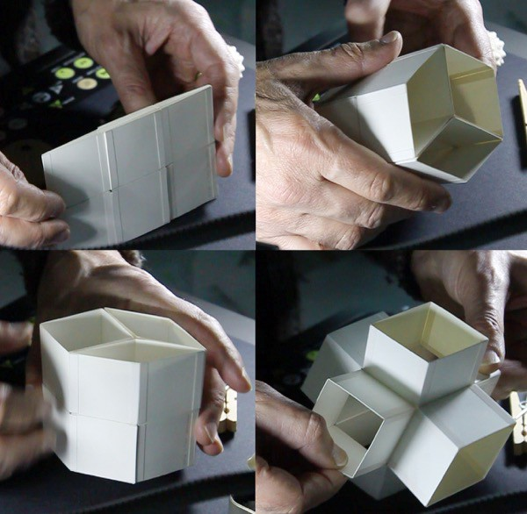

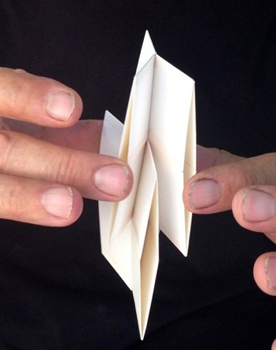

Scarpa, Untitled, 1996

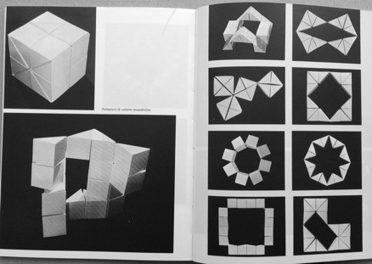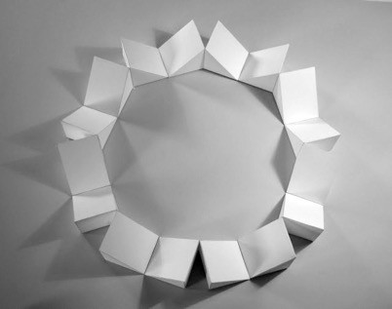

Scarpa, Models of Rotational Geometry
pp. 76–77

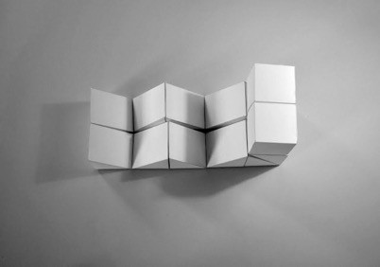
(L. Bocca, model replica, 2014)

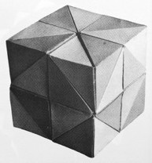
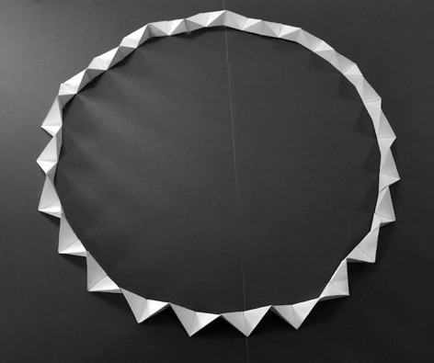


Scarpa, Models of Rotational Geometry, pp. 87–92 ^{(L.} ^{Bocca,} ^{model} ^{replica,} ²⁰¹⁴⁾

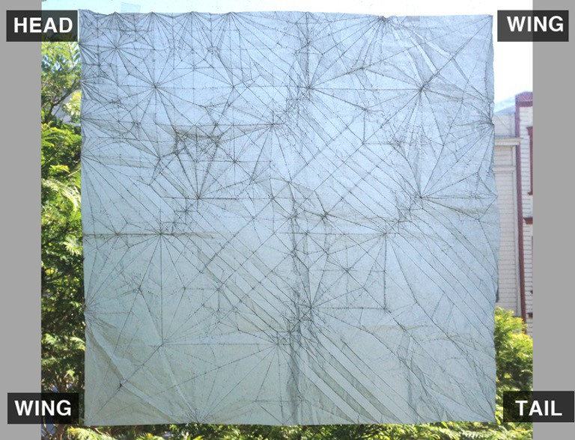

What animal does the origami crease pattern above yield? It’s one of the models found here:
Francesco Trogu — Origami models: http://trogu.blogspot.nl/search/label/Origami%20Models

THANK YOU!
PINO TROGU

BIOCLAMPING: ARISTOTLE’S LANTERN
GIORGIO SCARPA’S MODEL OF THE MASTICATORY APPARATUS OF THE SEA URCHIN… AND MORE.

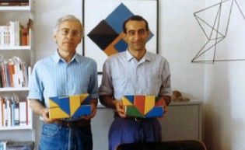
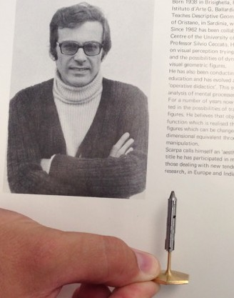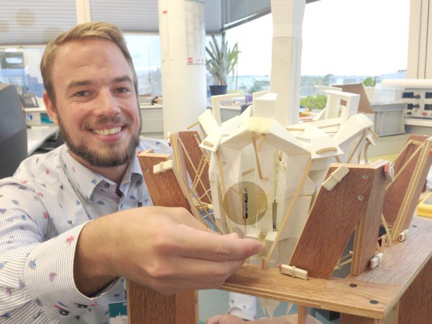

Giorgio Scarpa, Pino Trogu, 1988 Filip Jelínek, 2015

More videos...

Contact
trogu@sfsu.edu g.m.trogu@tudelft.nl go to first slide

